**FPT ACADEMY INTERNATIONAL**



## FPT – APTECH COMPUTER EDUCATION

**Mountaineering**

|  |  |  |  |
| --- | --- | --- | --- |
| **Center Name** | | FPT – Aptech – HCM2  Address: 590 Cach Mang Thang Tam, District 3, Ho Chi Minh City | |
| **Instructor** |  | Ms. Le Mong Thuy |  |
| **Class** |  | T1.2109.E0 |  |
| **Group** |  | 1 |  |
| **Group members** | | **Name** | **Student ID** |
|  |  | Nguyễn Văn Khoa | Student1337010 |
|  |  | Lê Thị Ngọc Huyền | Student1318434 |
|  |  | Nguyễn Phúc Duy | Student1333974 |
| **Duration** | Start date | 22th Nov 2021 |  |
| End date | 22th Dec 2021 |  |

**This is to certify that**

**Mr.:**

Nguyễn Văn Khoa

Lê Thị Ngọc Huyền

Nguyễn Phúc Duy

**Has successfully designed & developed**

eProject: Mountaineering website

**Submitted by:**

Nguyễn Văn Khoa

**Date of issue:**

22th Nov 2021

**Authorized Signature:**

TABLE OF CONTENTS

FPT – APTECH COMPUTER EDUCATION

ACKNOWLEGMENT 3

SYNOSIS 3

PROBLEM DEFINITION 3

CUSTOMER'S REQUIREMENTS SPECIFICATIONS (CRS) 4

SCOPE OF THE WORK (IN BRIEF) 6

ARCHITECTURE AND DESIGN OF THE SYSTEM 7

DIAGRAM OF THE WEBSITE 8

TASK SHEET REVIEW 1 9

SITE MAP 10

***MOCK OF THE WEBSITE***

HOMEPAGE 11

GUIDELINE 12

ABOUT MOUNTAINEERING 13

ORGANIZATION 14

CONTACT US 15

TASK SHEET REVIEW 2 16

WEBSITE DESCRIPTION

HOME PAGE 17

GUIDELINE 20

ABOUT MOUNTAINEERING 24

ORGANIZATION 33

CONTACT US 35

JAVASCRIPT DESCRIPTION 37

TASK SHEET REVIEW 3 40

# 

# ACKNOWLEGMENT

# On behalf of all the members of group 1, I would like to thank you all for the hard works, support to make this eProject complete successfully. Especially Ms. Le Mong Thuy, our teacher, she helped us a lot from the day that we started to study at FPT Aptech. With this eProject, she has guided us with her enthusiasm and rigor, because of her guidance, we would be able to finish this project. Besides, I want to thank all the team members of group 1, each of the team members has been working continuously in 4 weeks in order to complete this project.

# SYNOSIS

In this assignment, we were assigned to design and develop a website that provides detailed information about climbing activities. The purpose of this website is to reach customers who love to travel, experience and find information to be able to participate in mountain climbing activities, more than to satisfy their own passions. The website was born to facilitate customers to easily view detailed information to accumulate previous climbing experience. Besides, it also provides a number of rules, regulations, achievements, techniques and philosophy of climbing that are widely applied to customers.

# PROBLEM DEFINITION

Mountaineering, also called mountain climbing, the sport of attaining, or attempting to attain, high points in mountainous regions, mainly for the pleasure of the climb. Although the term is often loosely applied to walking up low mountains that offer only moderate difficulties, it is more properly restricted to climbing in localities where the terrain and weather conditions present such hazards that, for safety, a certain amount of previous experience will be found necessary. For the untrained, mountaineering is a dangerous pastime.

Unlike most sports, mountaineering lacks widely-applied formal rules, regulations, and governance; mountaineers adhere to a large variety of techniques and philosophies when climbing mountains.

You are required to develop a website which will give detailed information about mountaineering.

The website is to be developed for the Windows Platform using HTML5, JavaScript and Geolocation. The site should work well in all leading browsers including Chrome, IE, Firefox etc.

# CUSTOMER'S REQUIREMENTS SPECIFICATIONS (CRS)

**Client: Fpt Aptech.**

Business/Project Objective:

Mountaineering, or alpinism, is the set of outdoor activities that involves ascending tall mountains. Mountaineering-related activities include traditional outdoor climbing, skiing and traversing via ferratas. Indoor climbing, sport climbing and bouldering are also considered variants of mountaineering by some. You are supposed to create a website for them with the below mentioned requirement specifications.

The website is to be developed for the Windows Platform using HTML5, JavaScript and Geolocation. The site should work well in all leading browsers including Chrome, IE, Firefox etc.

**Input to the system:**

* Searching information about mountaineering: History, Types/Styles, Techniques, Sheltering, Hazards, Equipments, Organizations.

**Output from the system:**

* + - * A menu that will categorize all the functions of the site:
      * Introduction to mountaineering.
      * Display history, techniques/styles of mountaineering.
      * Display shelter, hazards/hardship when mountaineering.
      * Display various pictures, videos of mountaineering.
      * Displays the latest developments in the climbing field.
      * Display the details of some item, equipment used for mountaineering (brand, material, price, etc.).
      * A guideline that shows tips and helps users on what to prepare for a mountaineering trip.
      * Site should be able to provide brief information of organizations(history, country, members...).
      * Displays our team's location and contact information.

**Process**:

* + - * In the Organizations site, users can select and see various success stories of organized camps.

**Expected delivery date:** 22th-December-2021

**List of deliverables:**

* + - * Document Word.
      * Source code.

**Hardware/ Software Requirements:**

* **For developer**

**Hardware**

* + Intel Pentium 4 processor or higher
  + 1 Gigabytes of RAM or higher

**Software**

* + Windows 7 OS or higher
  + Adobe Dreamweaver
  + IE 5.0/ Netscape 6.0
  + Web browsers such as IE, Chrome or Firefox are supporting HTML5, CSS3 and Javascript.
* **For web users**

**Hardware**

* + Intel Pentium 4 processor or higher
  + 512 Megabytes of RAM or higher

**Software**

* + Windows XP OS or higher
  + Web browsers such as IE, Chrome or Firefox are supporting HTML5, CSS3 and Javascript.

# SCOPE OF THE WORK (IN BRIEF)

After a long and detailed discussion, our group has decided to create a website contain the following webpage:

1. **Homepage (contain basic information about mountaineering)** : We divided the section into 4 parts:
   * + *Part 1: Display section in carousel/slides: images/videos of mountaineer*
     + *Part 2: The latest developments in the field of climbing.*
     + *Part 3: Display some records of mountaineering in the past.*
     + *Part 4: Display some popular mountain each months.*
2. **Guideline:** Display guideline,tips and tricks. Information and what to prepare before a mountaineering trip.
3. **About Mountaineering:** We divide this section into 5 subpages::

*-* Display climbing history.

- Display some styles of mountaineering.

- Display some terrain and techniques of mountaineering.

- Display some shelter when mountaineering.

- Display hazards, hardship of mountaineering.

1. **Organizations:** Display groups/organizations/clubs that arrange mountaineering and some success stories of organized camps.
2. **Contact Us**: Contact info page.

# Architecture and design of the system

**SERVER**

Webpage request



Requested Page

**RENDERING**

**ENGINE**

**CSS CODE**

**HTML CODE**

**WEB SERVER**

**WEB BROWSER**

**CLIENT**

# Diagram of the website

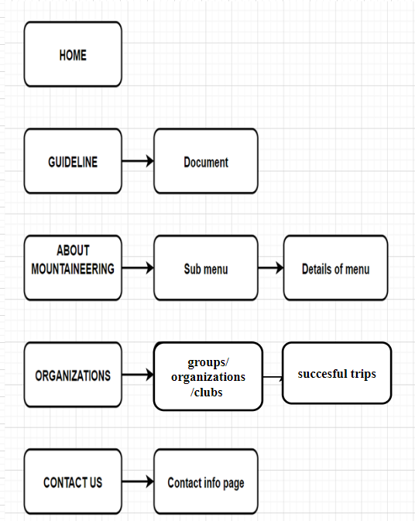



# TASK SHEET REVIEW 1

|  |  |  |  |  |  |  |  |
| --- | --- | --- | --- | --- | --- | --- | --- |
| **Project Ref. No.:**  **eP/Advertisement Portal Management**  **System/01** | | **Project Title:** | **Activity Plan Prepared By:** | **Date of Preparation of Activity Plan:** | | | |
| **Sr.**  **No.** | **Task** | **Actual**  **Start Date** | **Actual Days** | **Team Mate Names** | **Status** |
| 1 | Problem Statement | Mountaineering | Nguyễn Văn Khoa | 24-Nov-21 | 1 | L.T.N.Huyền | Completed |
| 2 | Requirements analysis for climbing activities | 24-Nov-21 | 1 | N.P.Duy | Completed |
| 3 | The scope of the work (in brief) | 24-Nov-21 | 1 | All | Completed |
| 4 | Architecture and design of the system | 24-Nov-21 | 1 | All | Completed |
| 5 | Diagram of the website | 24-Nov-21 | 1 | All | Completed |
| 6 | Task Sheet | 24-Nov-21 | 1 | N.V.Khoa | Completed |

|  |  |
| --- | --- |
| **Date: 24th Nov 2021** | |
| Signature of Instructor:  **Ms. Le Mong Thuy** | Signature of Team Leader:    **Nguyen Van Khoa** |

# SITE MAP

|  |
| --- |
|  |

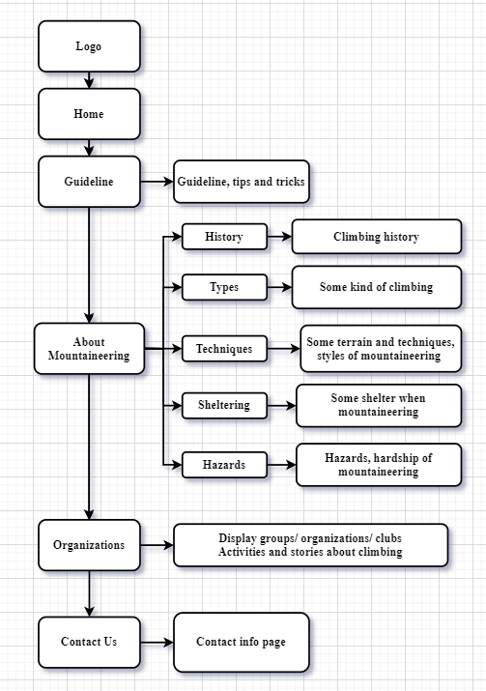

**MOCK OF THE WEBSITE**

1. **Homepage**

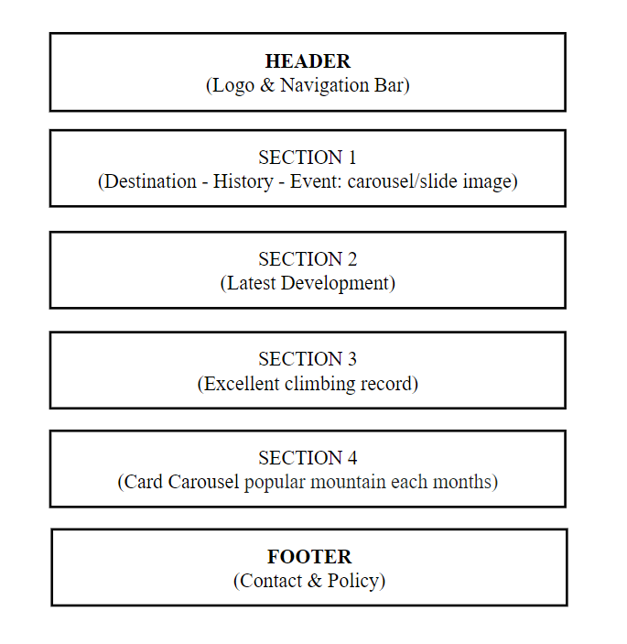

1. 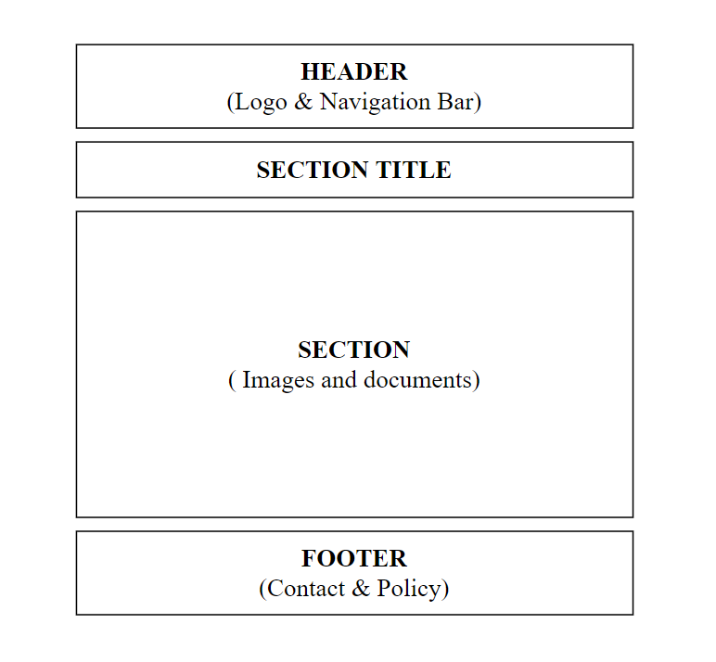**Guideline**
2. **About mountaineering (History, styles, terrain and techniques, shelter, hazards)**

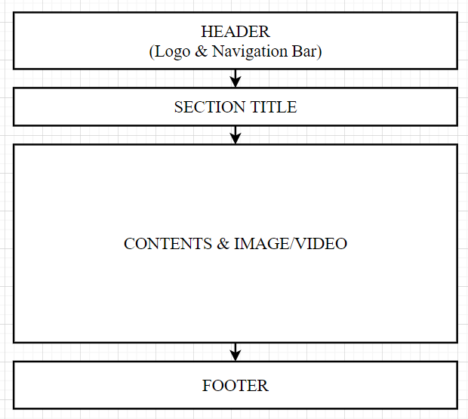

1. 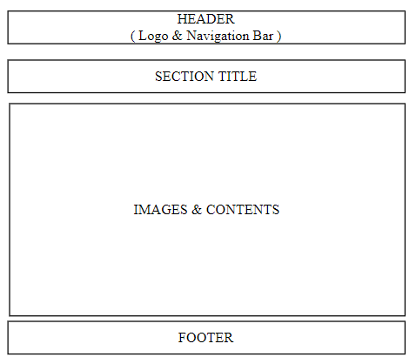**Organizations**
2. 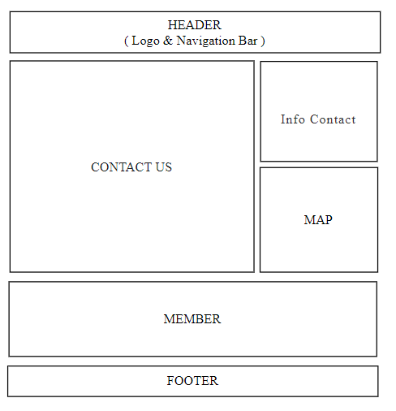**Contact Us**

# TASK SHEET REVIEW 2

|  |  |  |  |  |  |  |  |
| --- | --- | --- | --- | --- | --- | --- | --- |
| **Project Ref. No.:**  **eP/Advertisement**  **Portal Management System/01** | | **Project Title:** | **Activity Plan Prepared By:** | **Date of Preparation of Activity Plan:** | | | |
| **Sr.**  **No.** | **Task** | **Actual Start Date** | **Actual Days** | **Team Mate Names** | **Status** |
| 1 | Site map | Mountaineering | Nguyễn Văn Khoa | 26th-Nov-2021 | 1 | All | Completed |
| 2 | Mock of the website | 26th-Nov-2021 | 1 | All | Completed |
| 3 | Task sheet | 26th-Nov-2021 | 1 | All | Completed |

|  |  |
| --- | --- |
| **Date: 26th Nov 2021** | |
| Signature of Instructor:  **Ms. Le Mong Thuy** | Signature of Team Leader:  **Nguyen Van Khoa** |

WEBSITE DESCRIPTION

1. HOME PAGE.
   1. **Description**

**Home page displays following infomation**

* + - * Events
      * New Developments
      * Some climbing records Screenshot
  1. 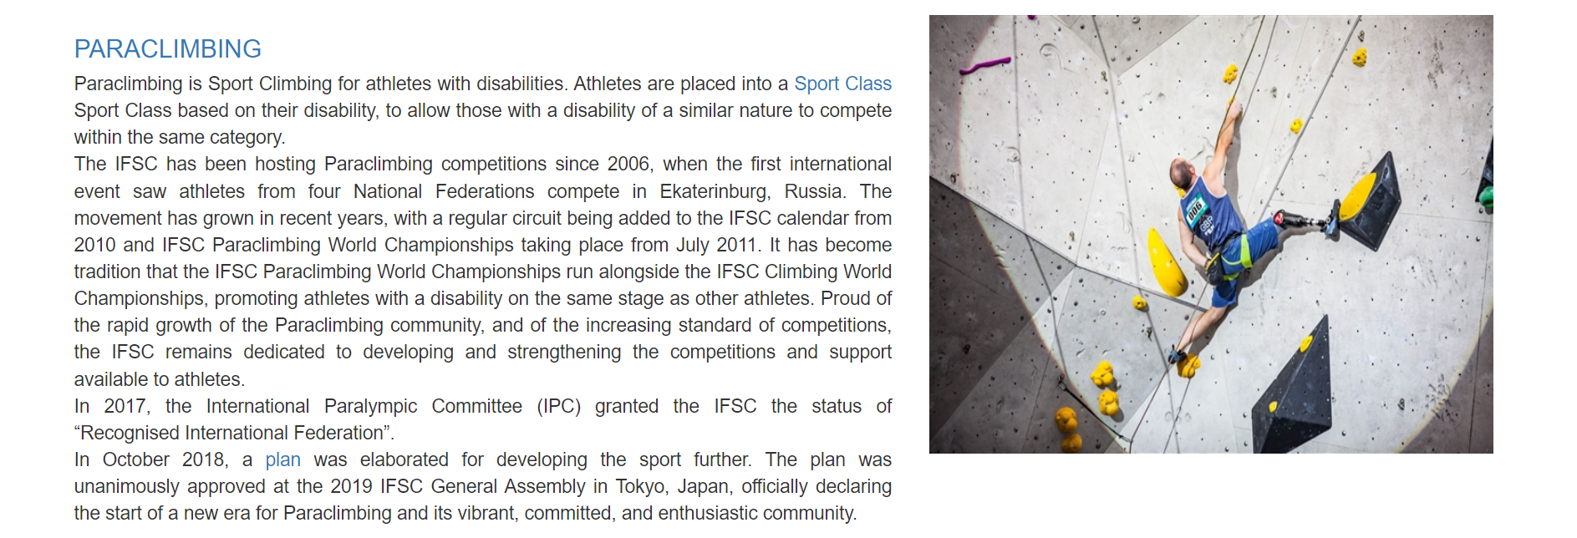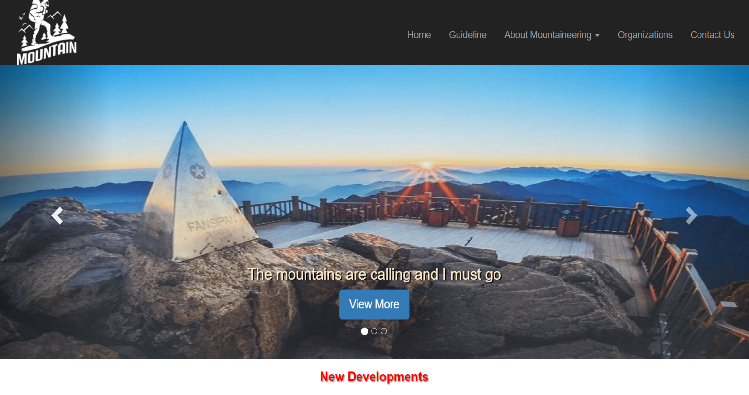**Screenshot**

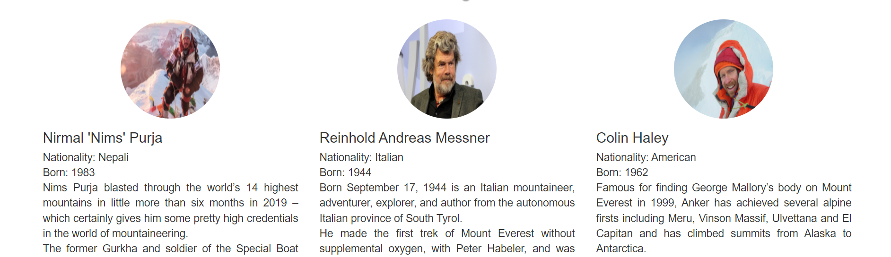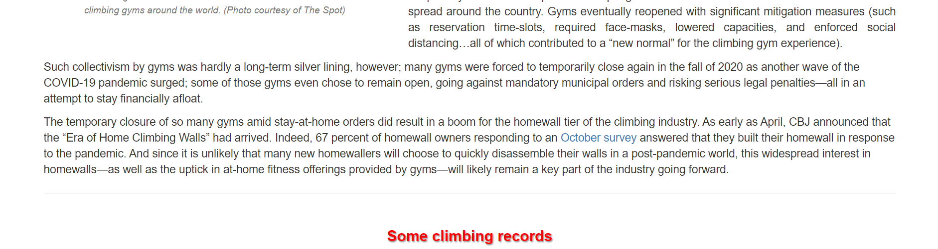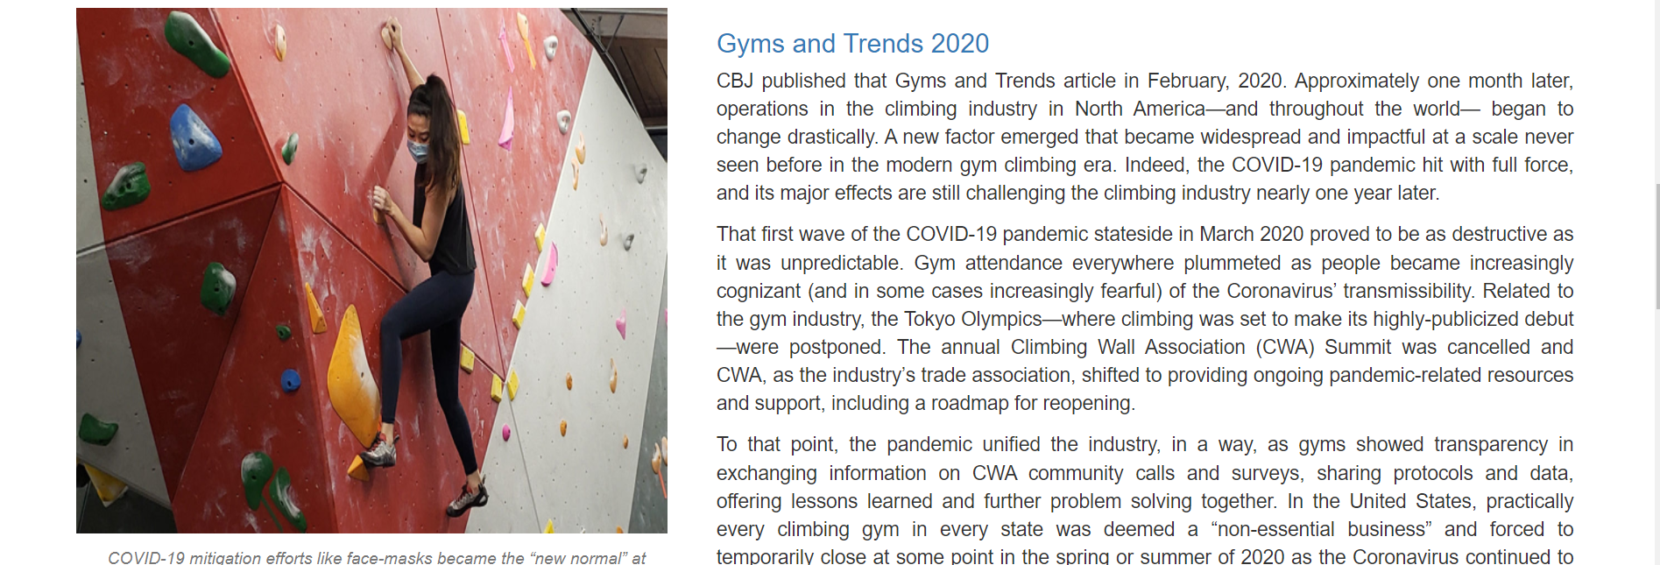**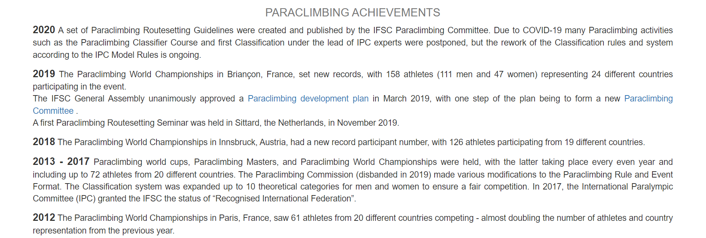

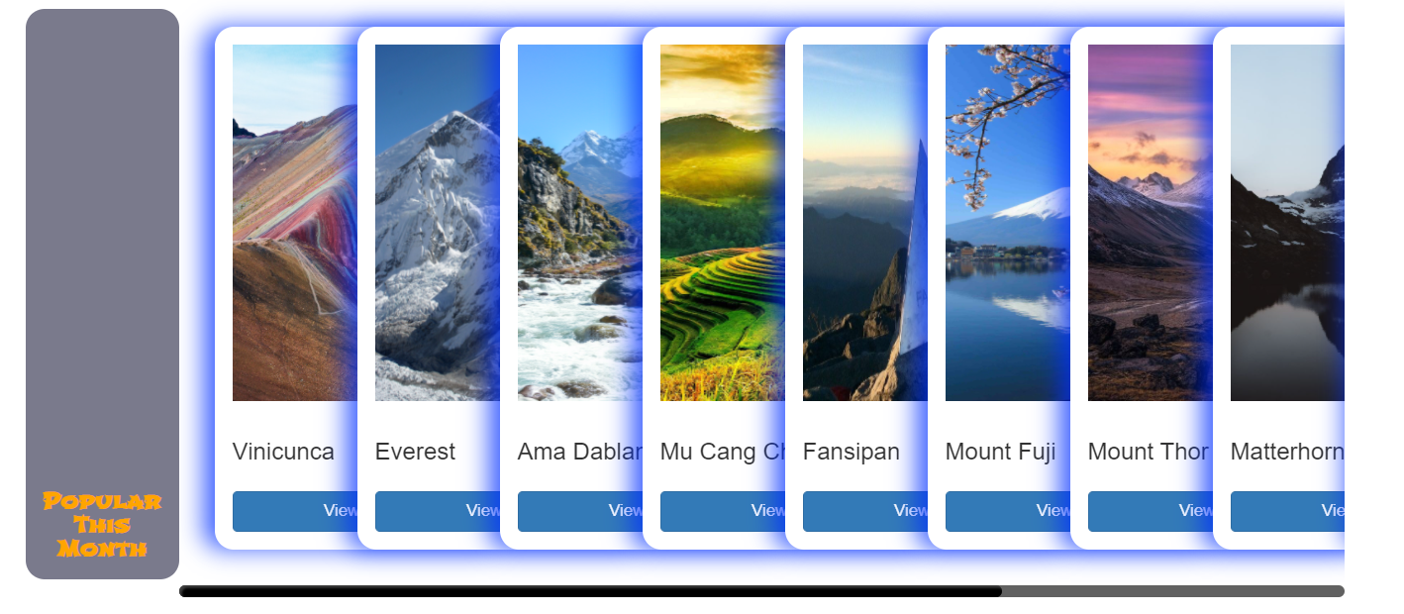**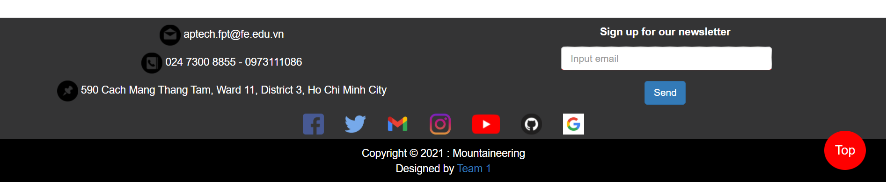***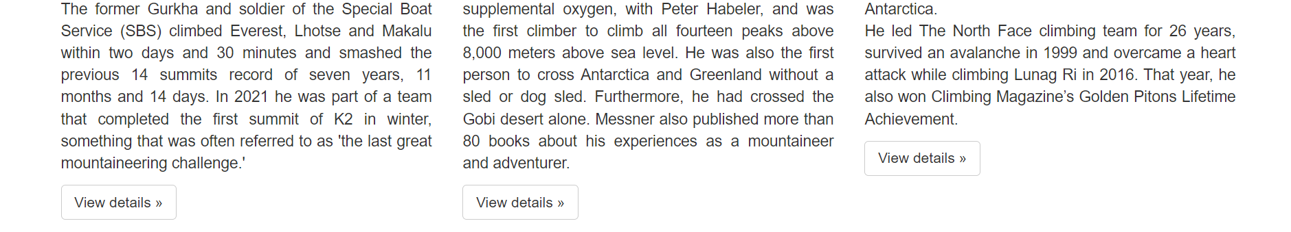*

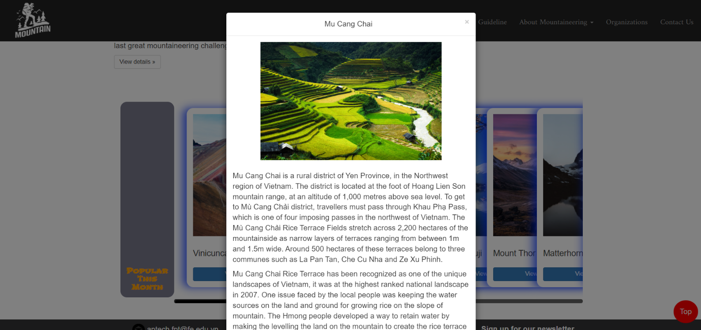

1. Guideline
2. **Description:**
   * + - Show step-by-step guide on how to start mountaineering
3. **Screenshot:**

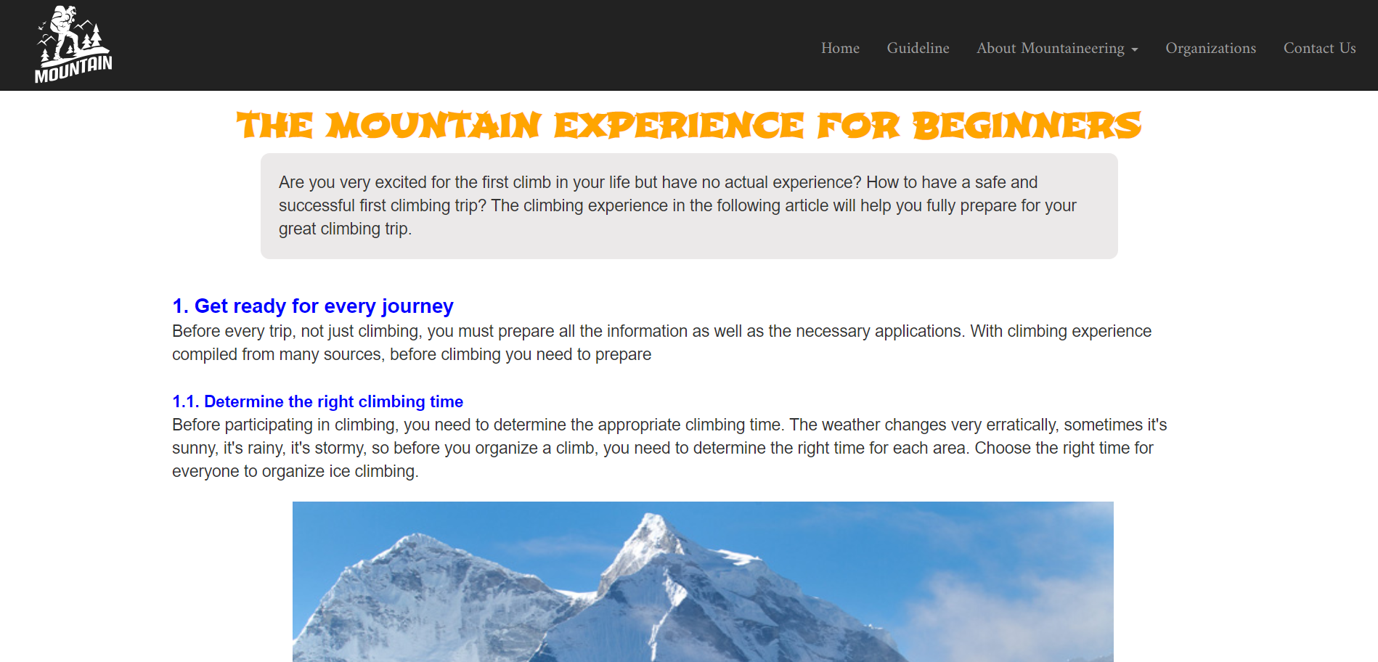

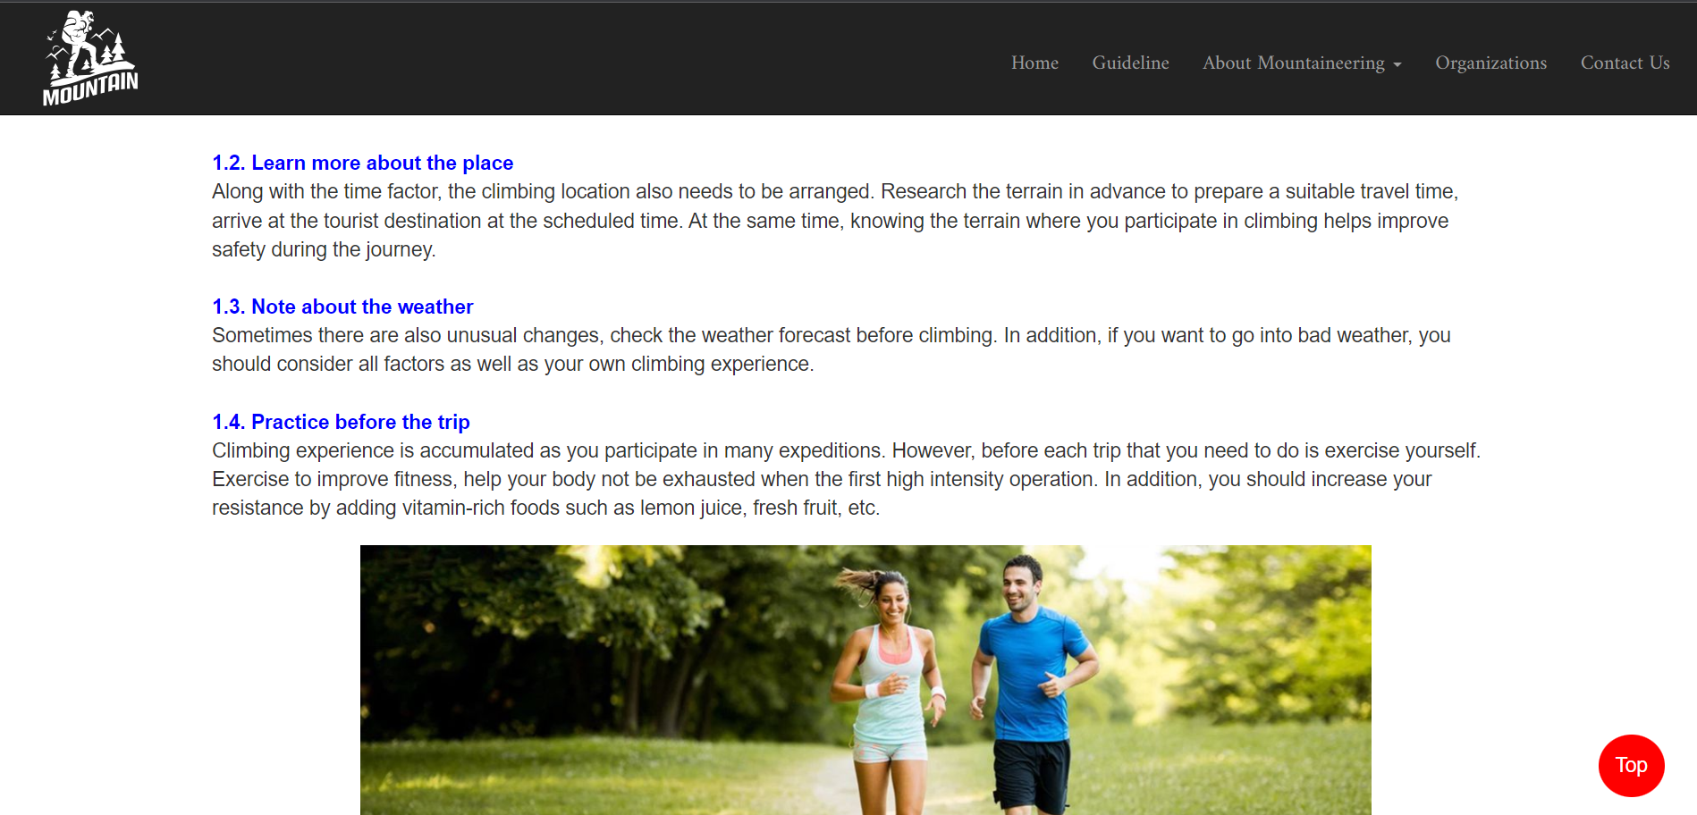

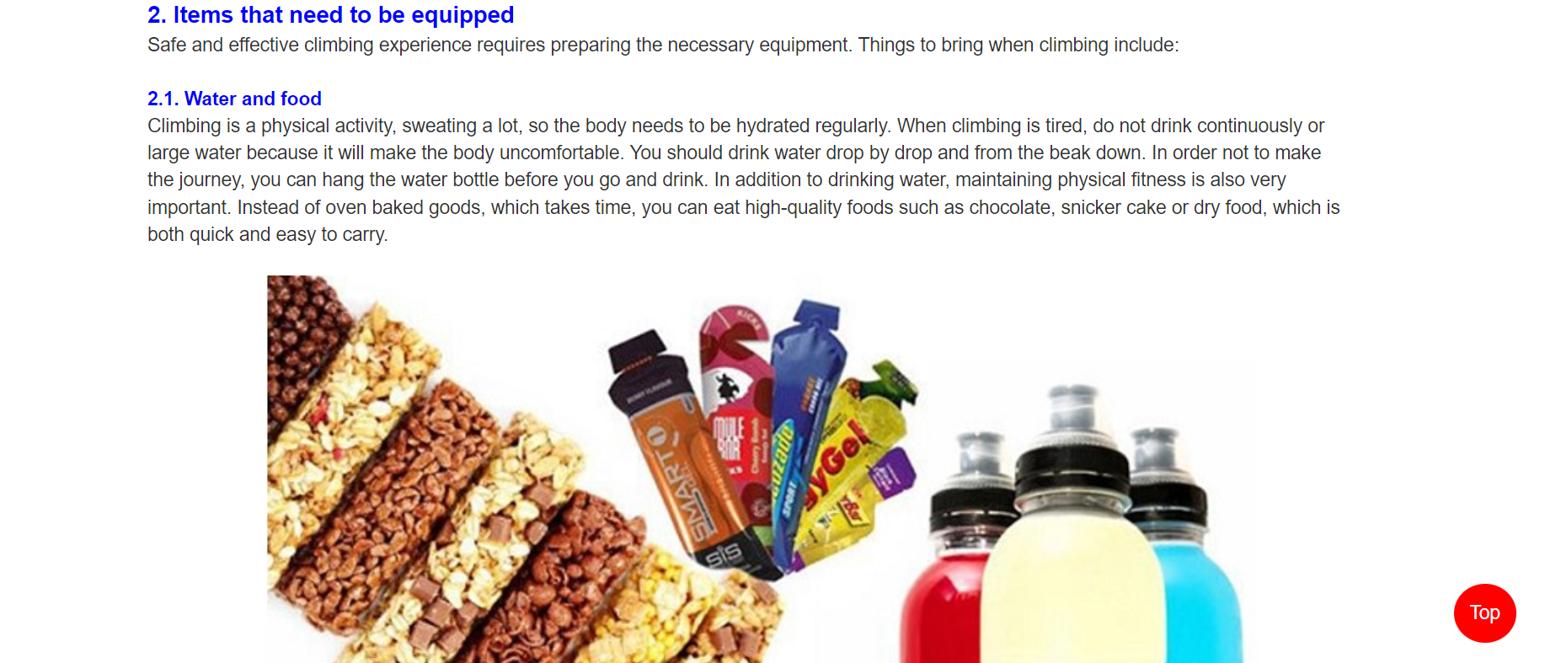

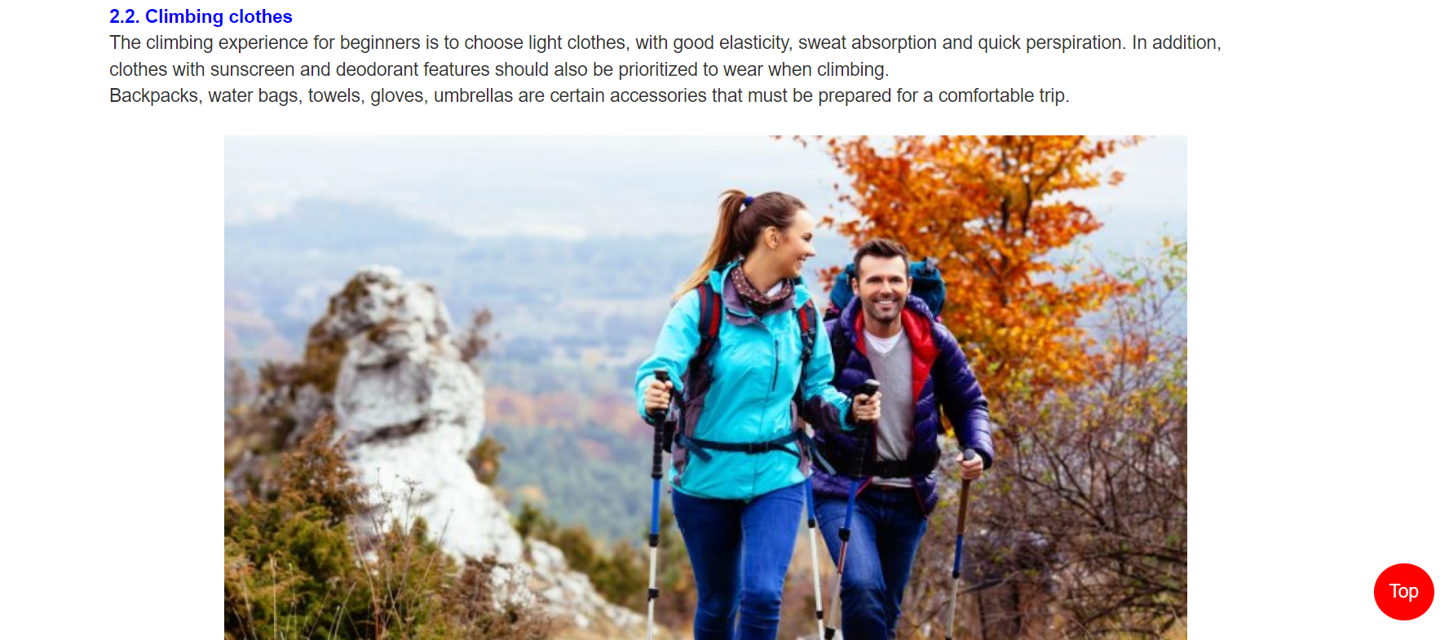

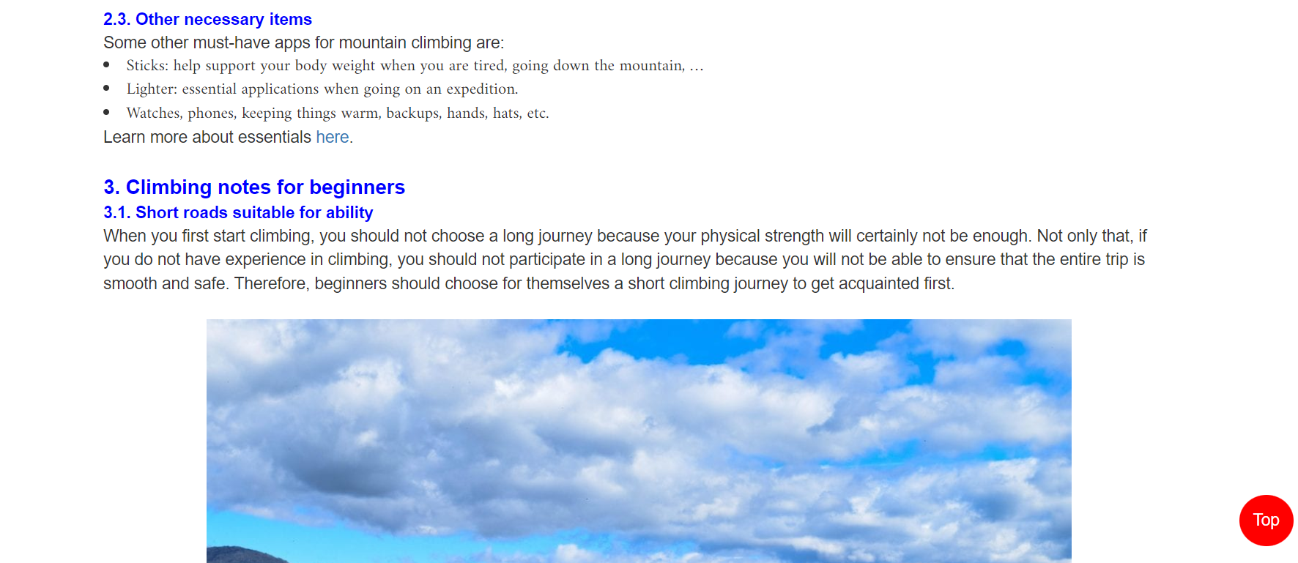

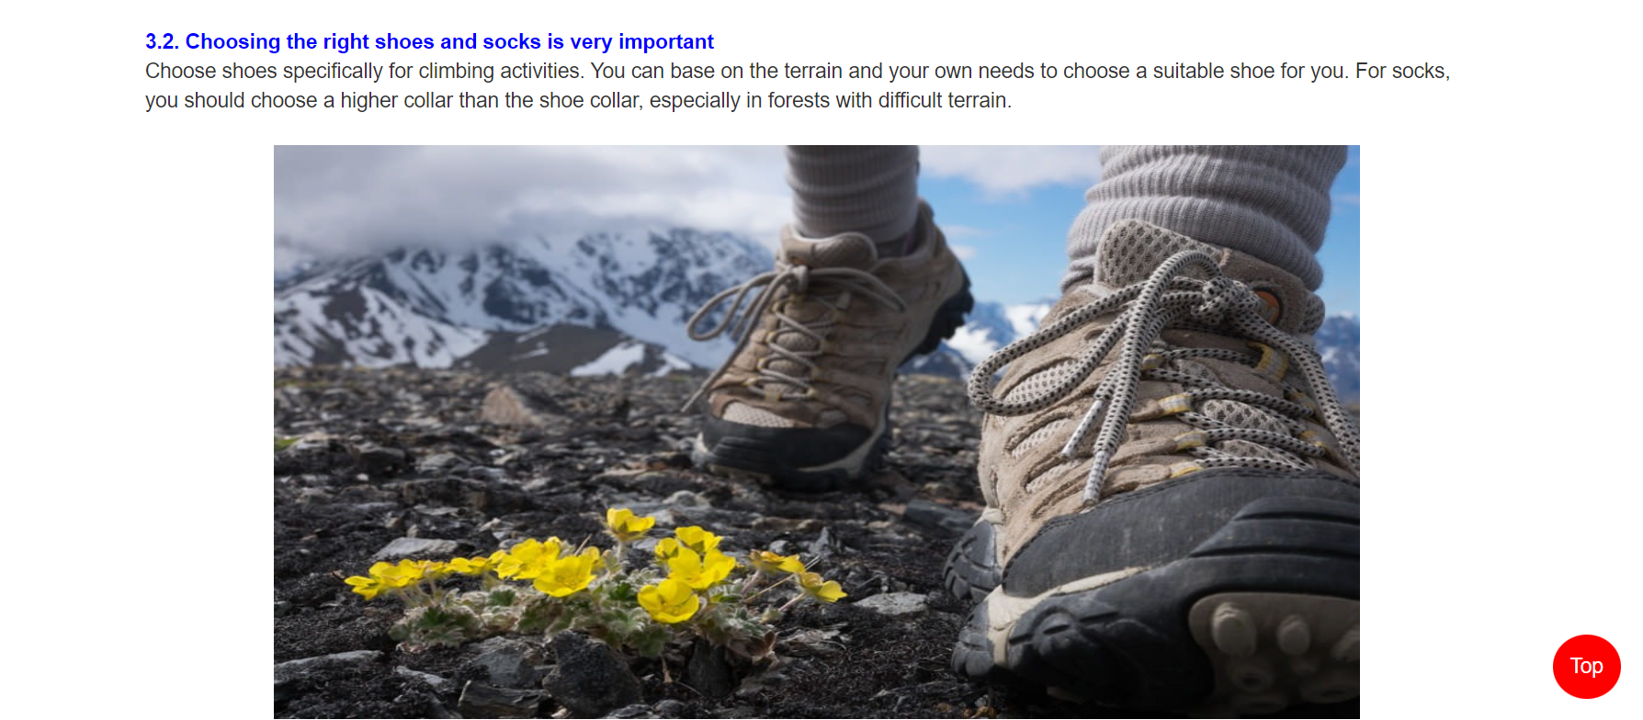

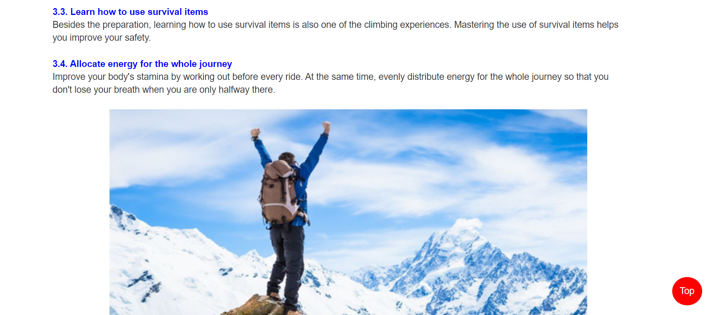

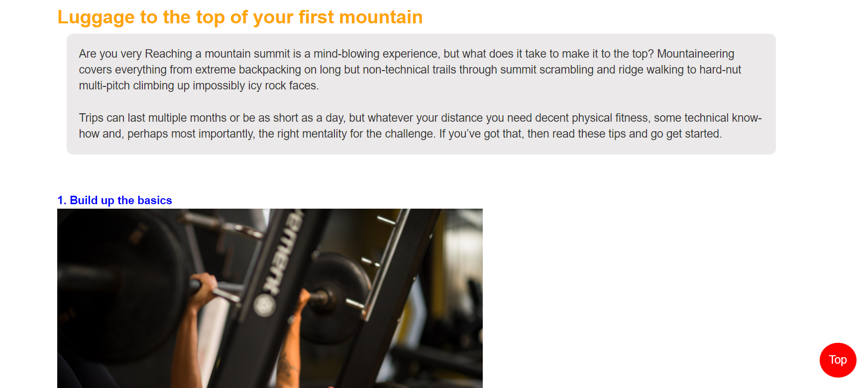

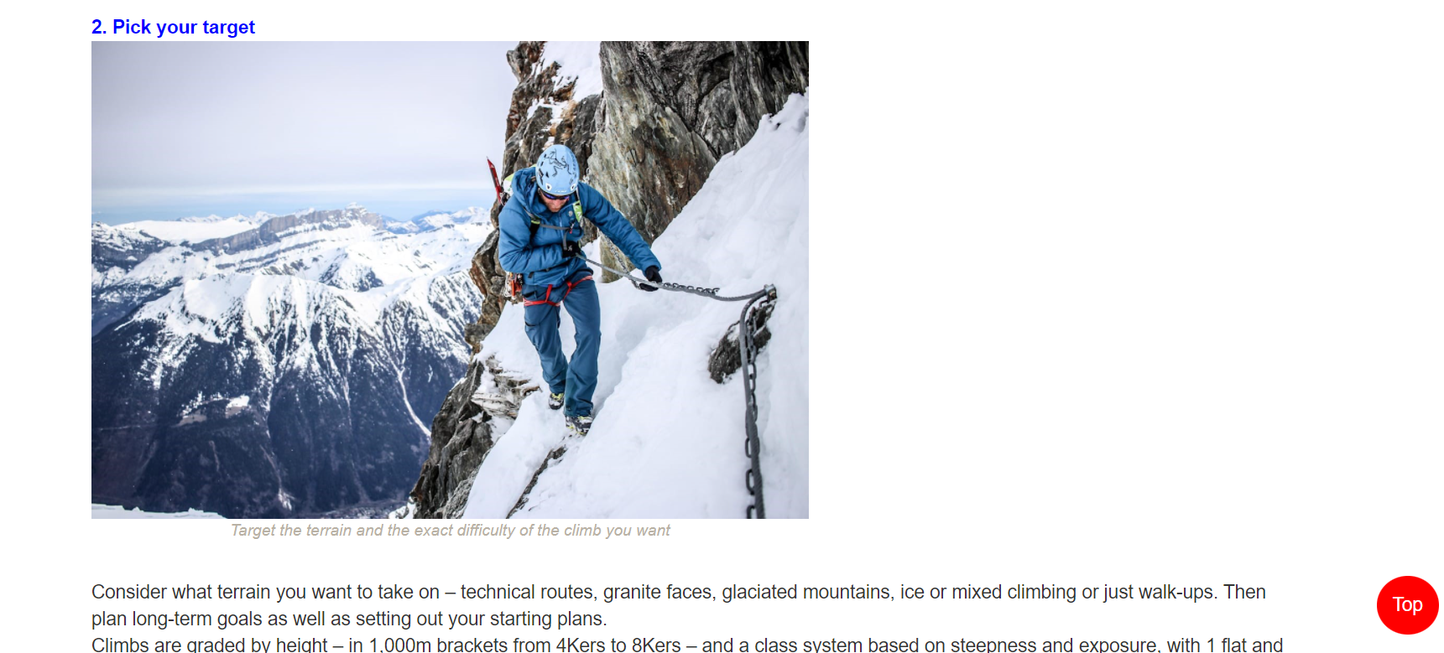

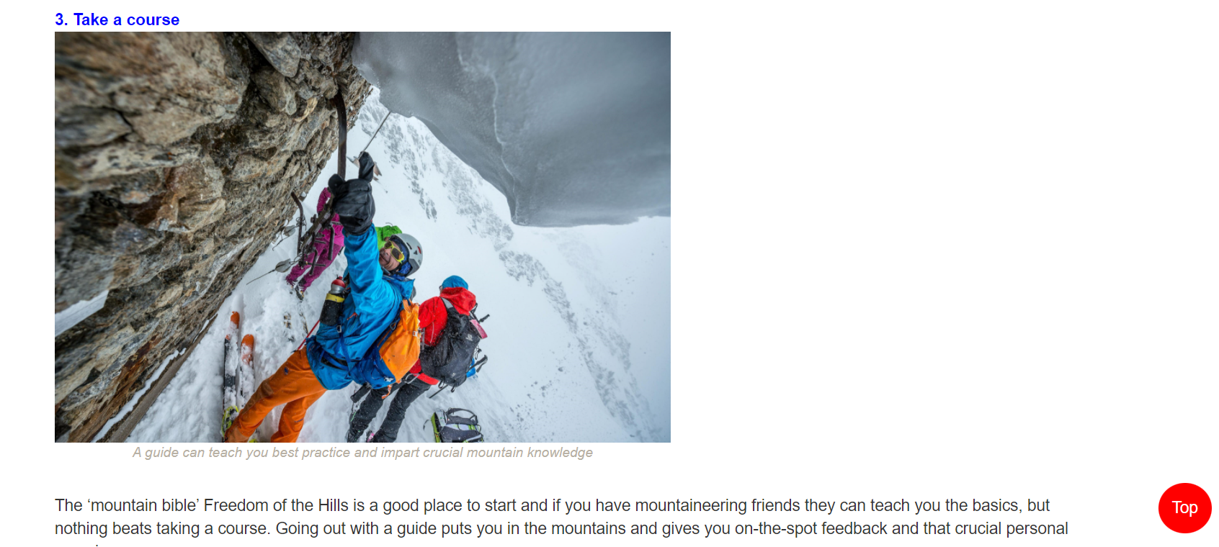





3. A bout Mountaineering (History, styles, terrain and techniques, shelter, hazards)

**a) Description:**

* **About Mountaineering** page divided into 5 part :

**+ History:** display information about history of mountaineering

**+ Type:** display information about type of mountaineering

**+ Techniques:** display information about techniques of mountaineering

**+ Sheltering:** display information about different type of shelter when mountaineering

**+ Harzards:** display information about hazards

1. **Screenshot:**

**History:**

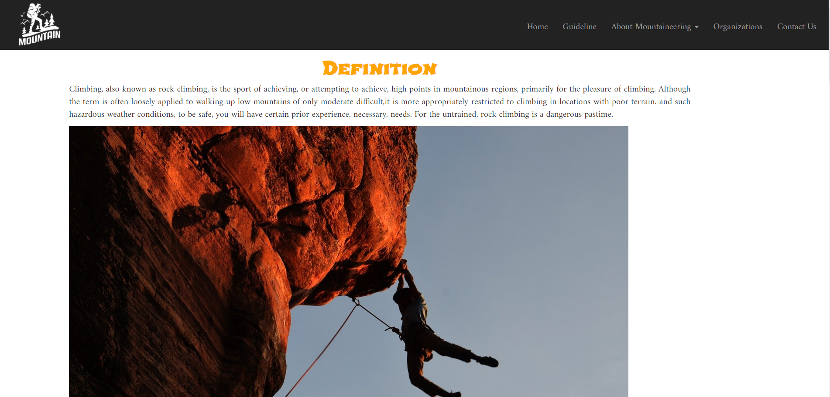

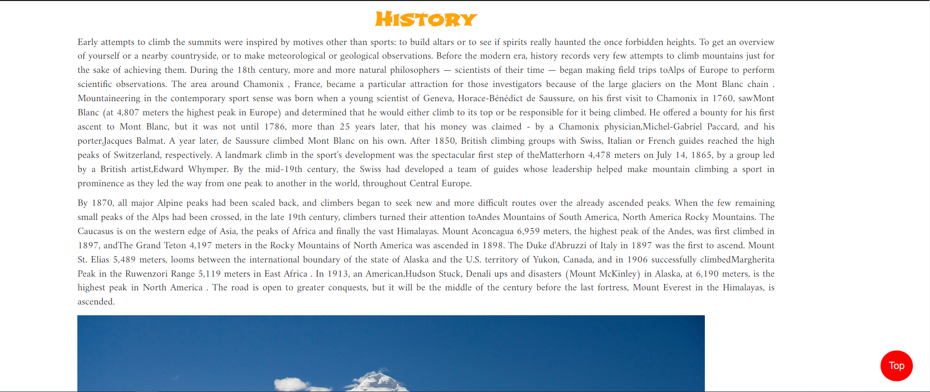

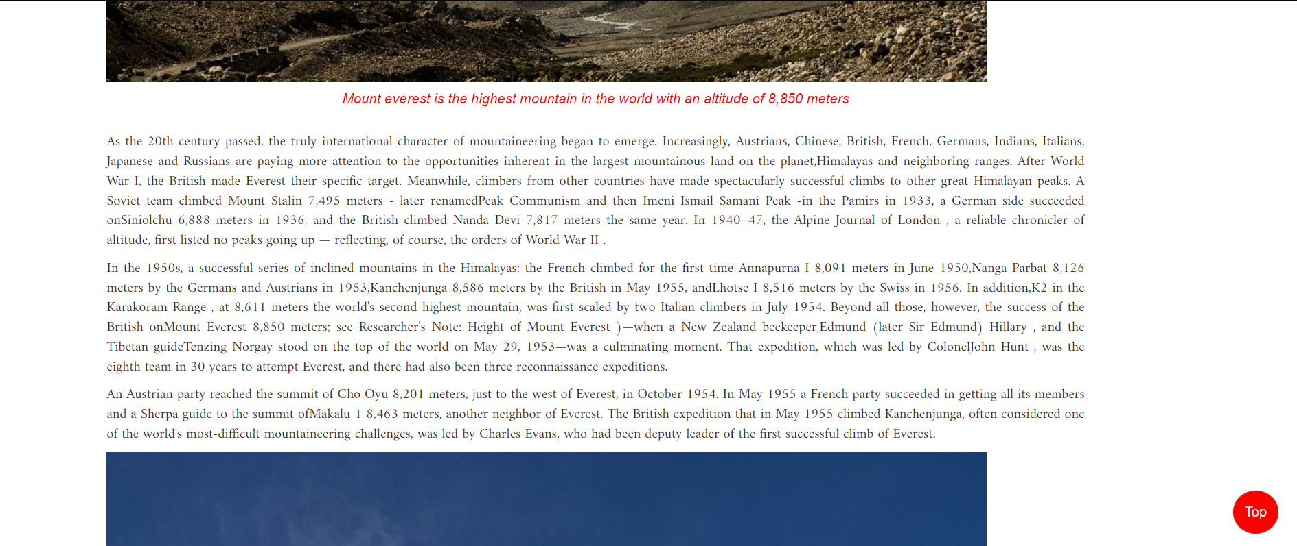

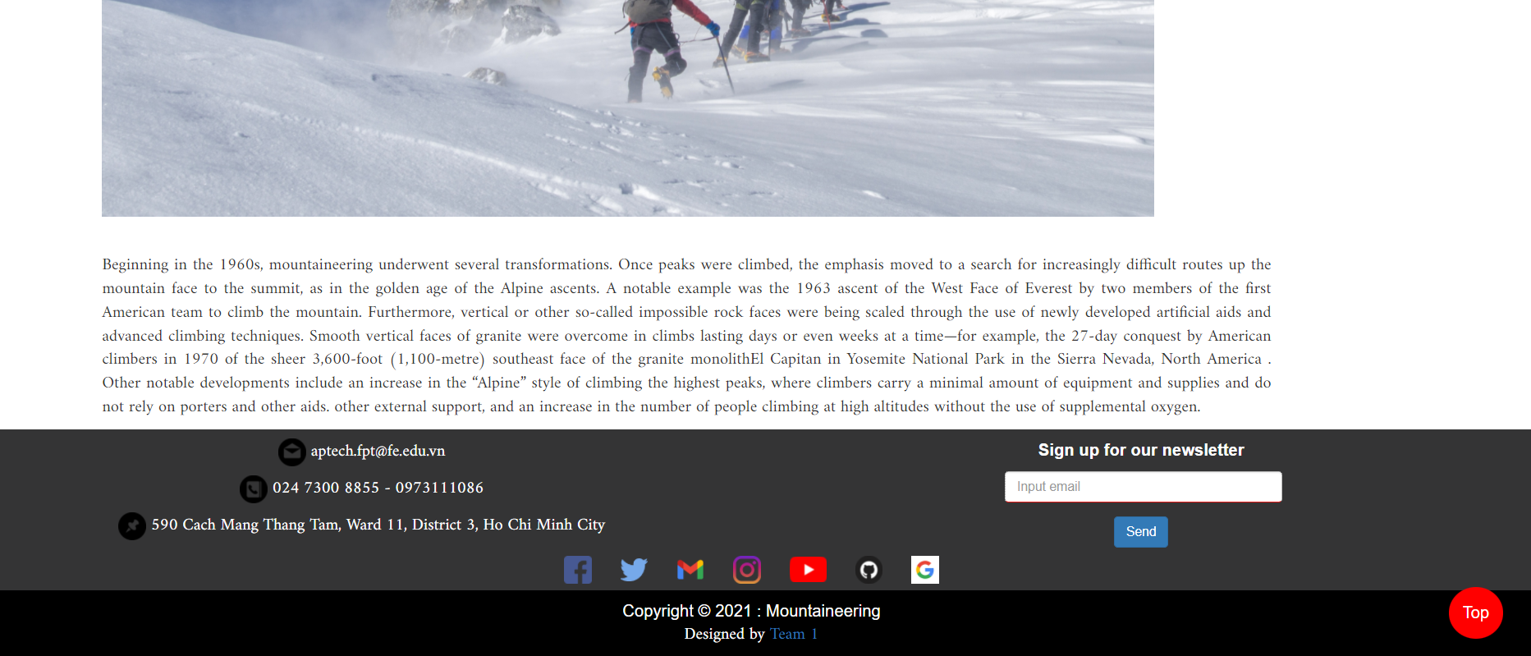

**Type**

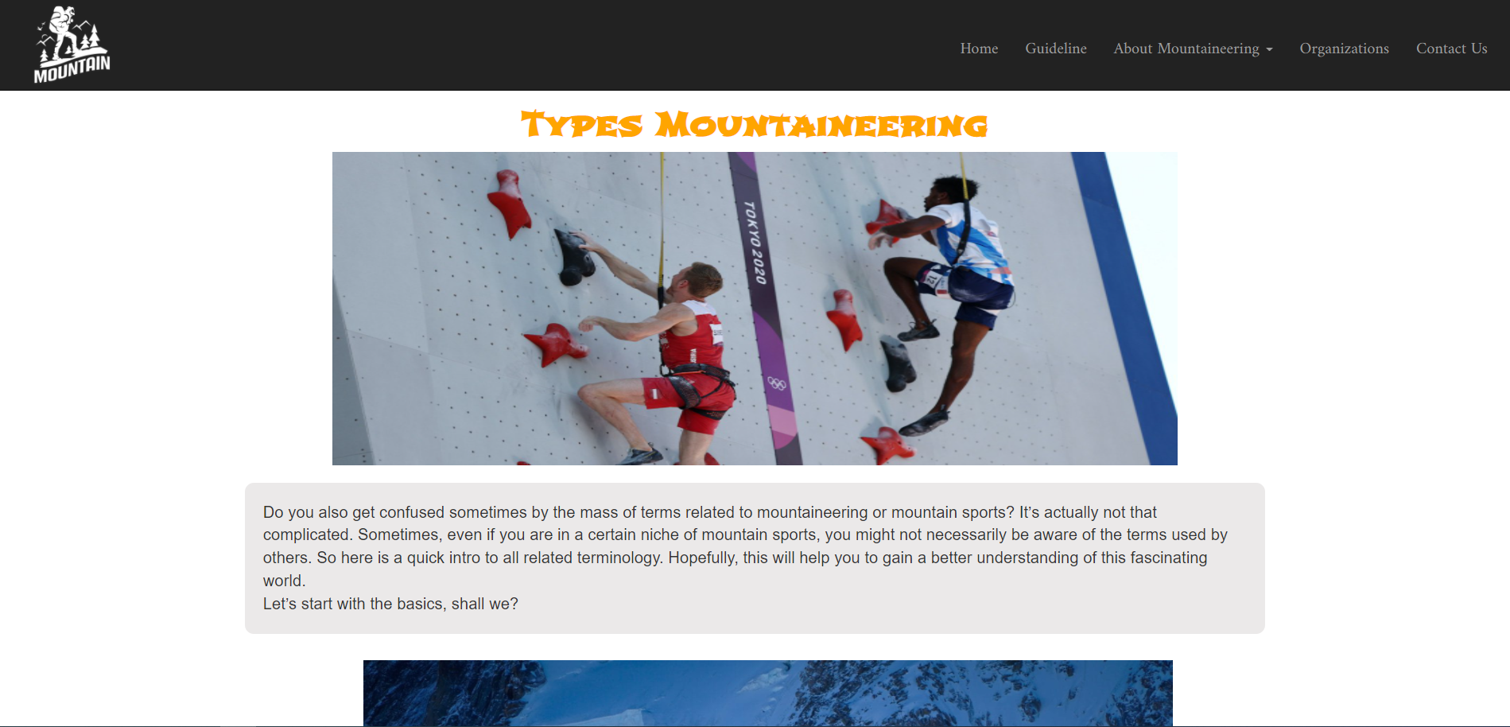

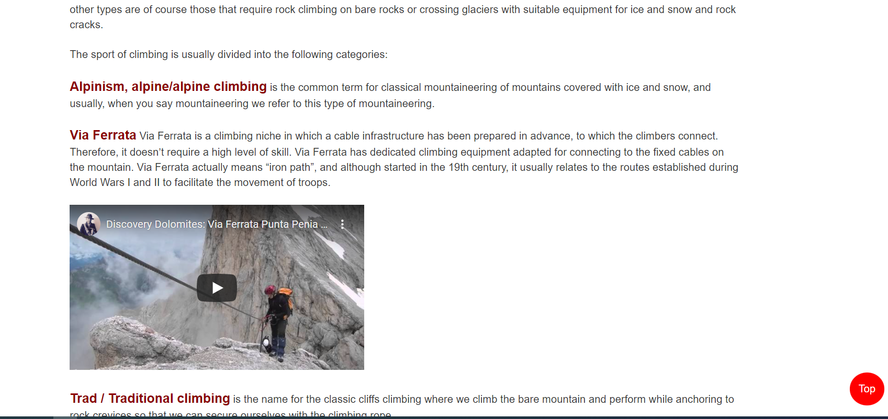

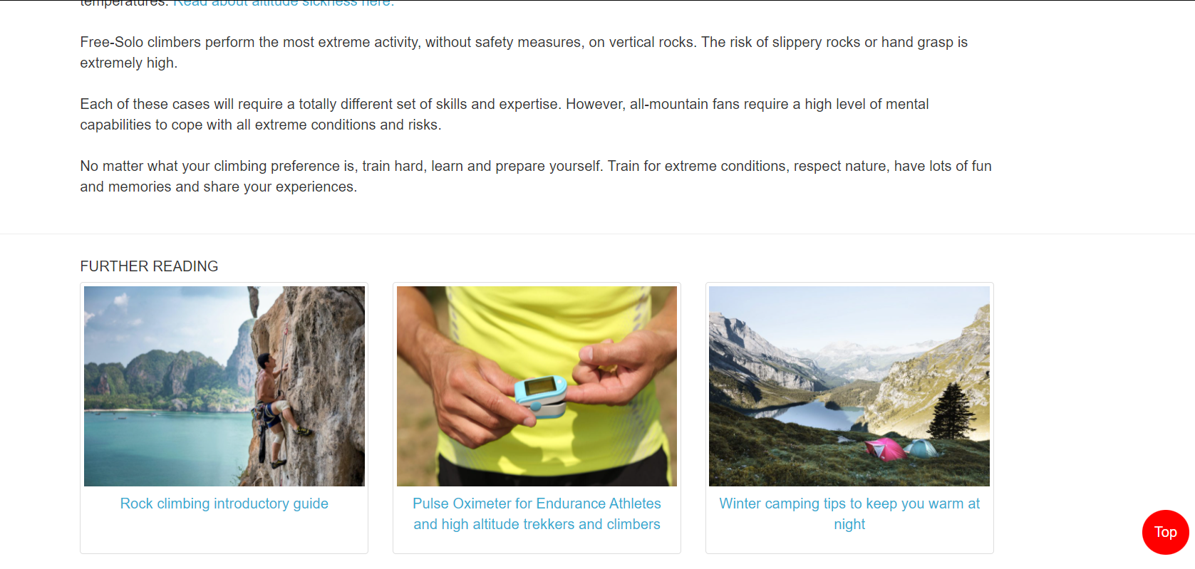

**Techniques**

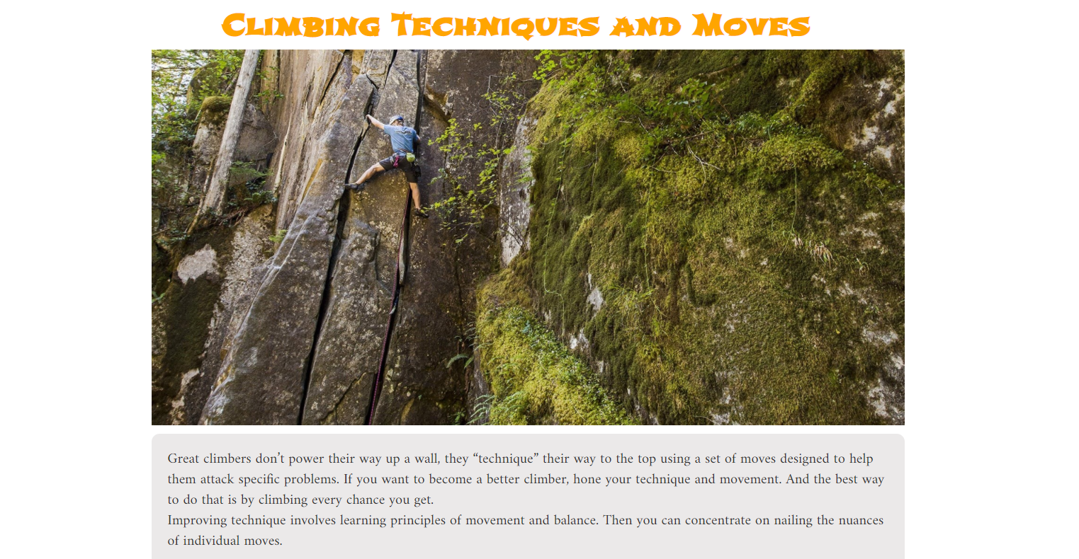

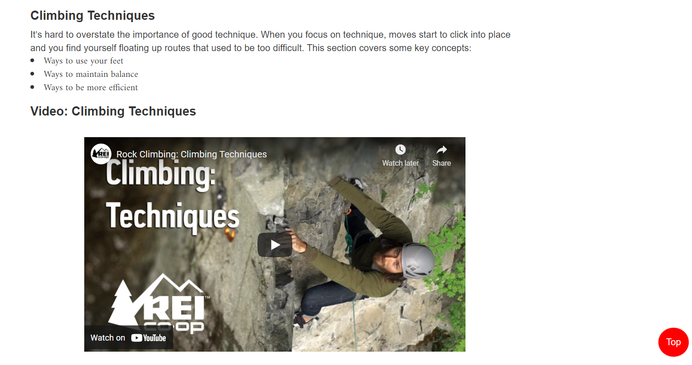

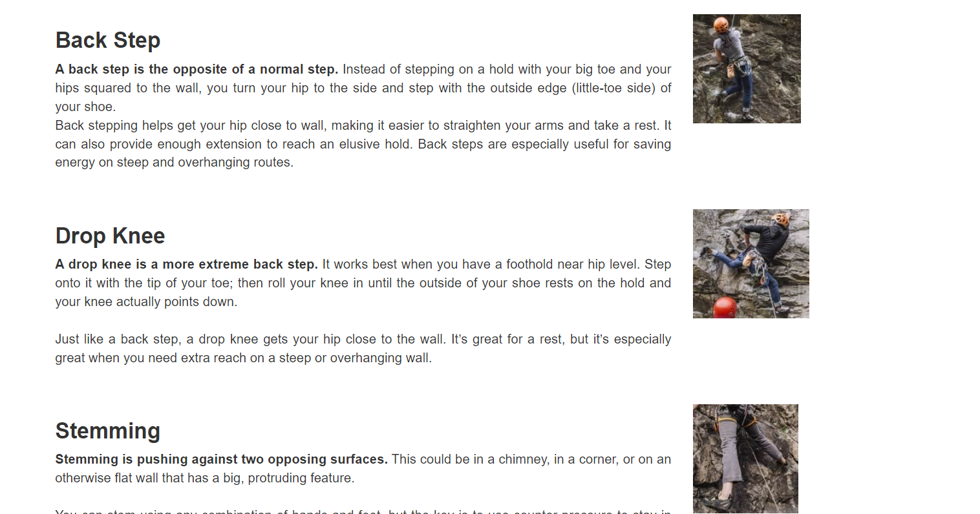

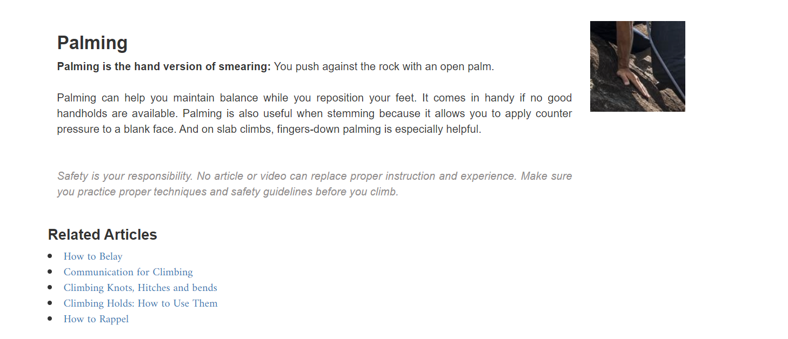

**Sheltering:**

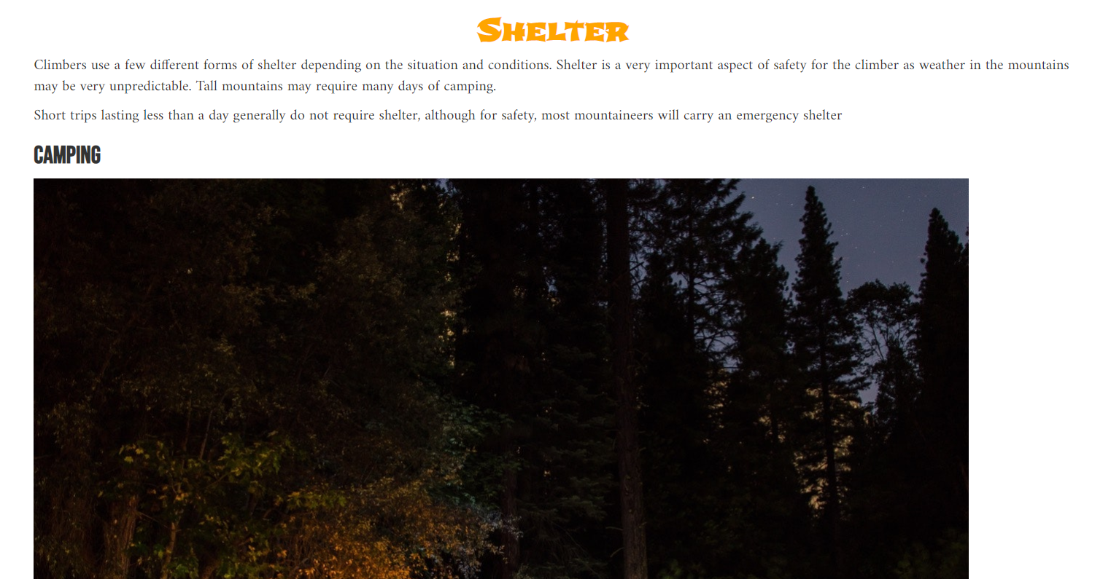

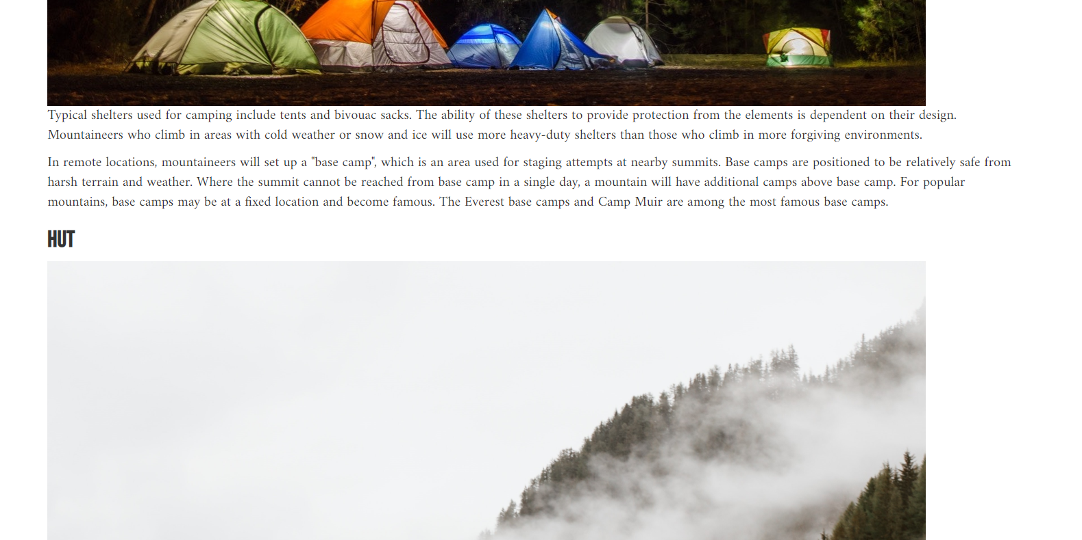

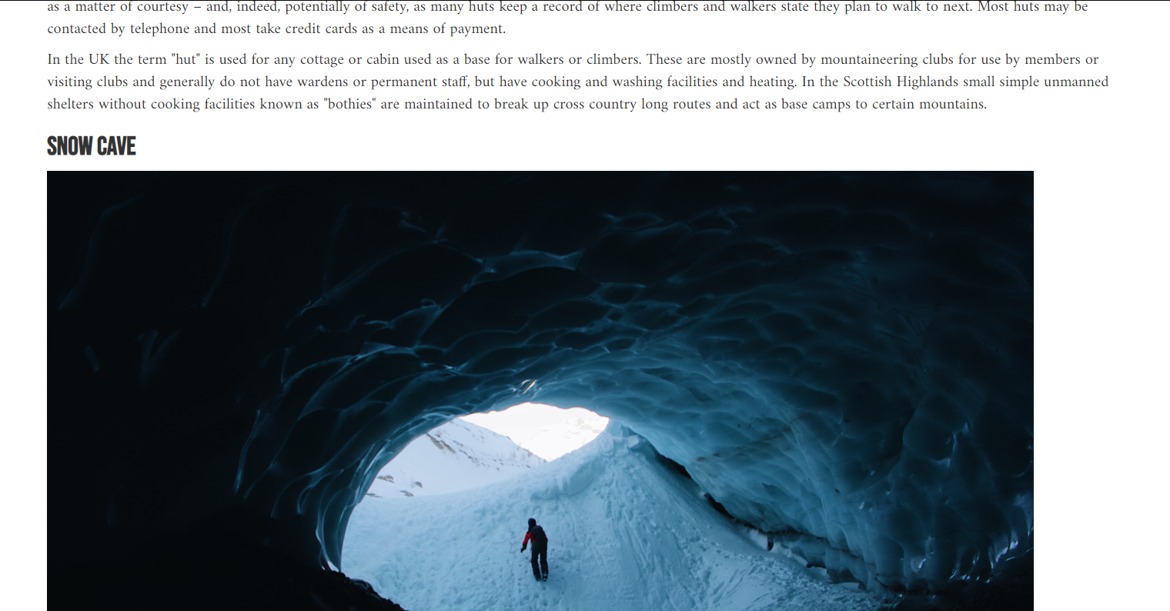

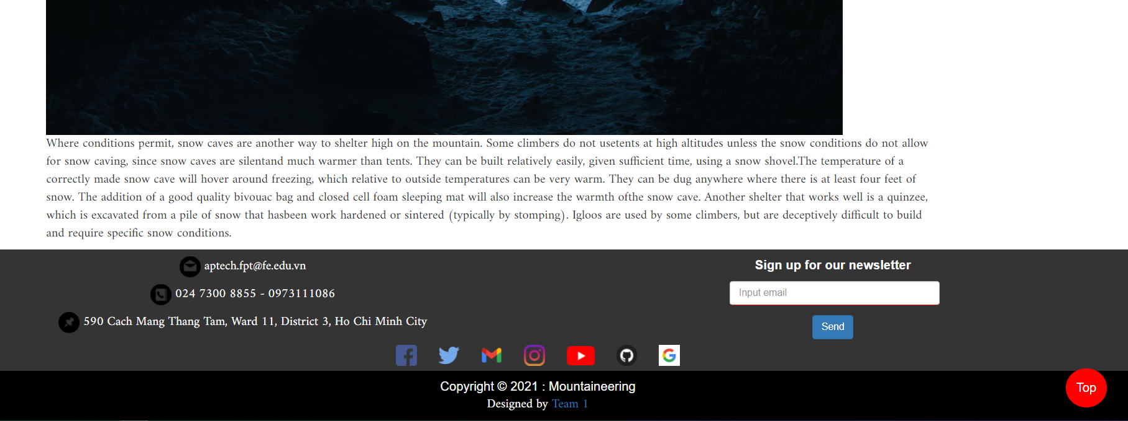

**Harzards:**

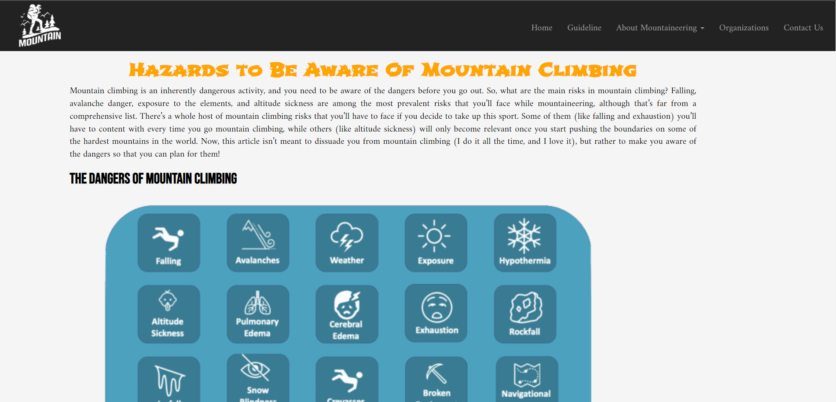

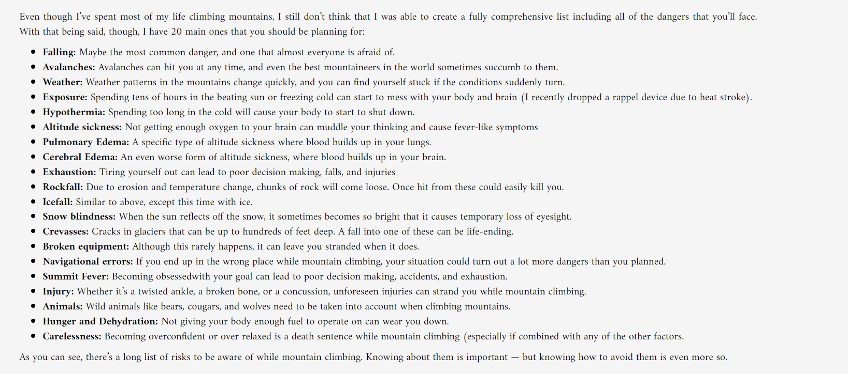

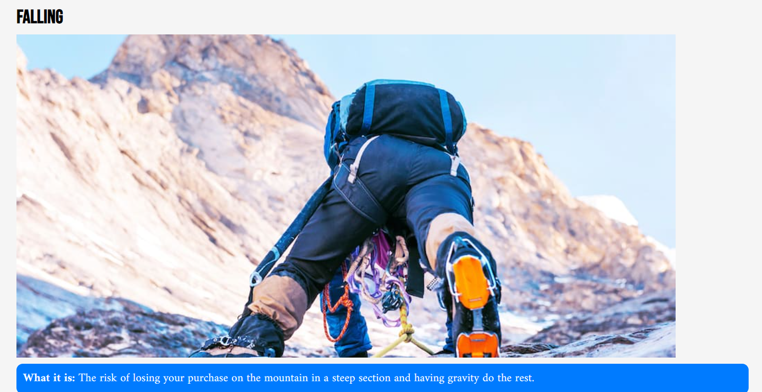

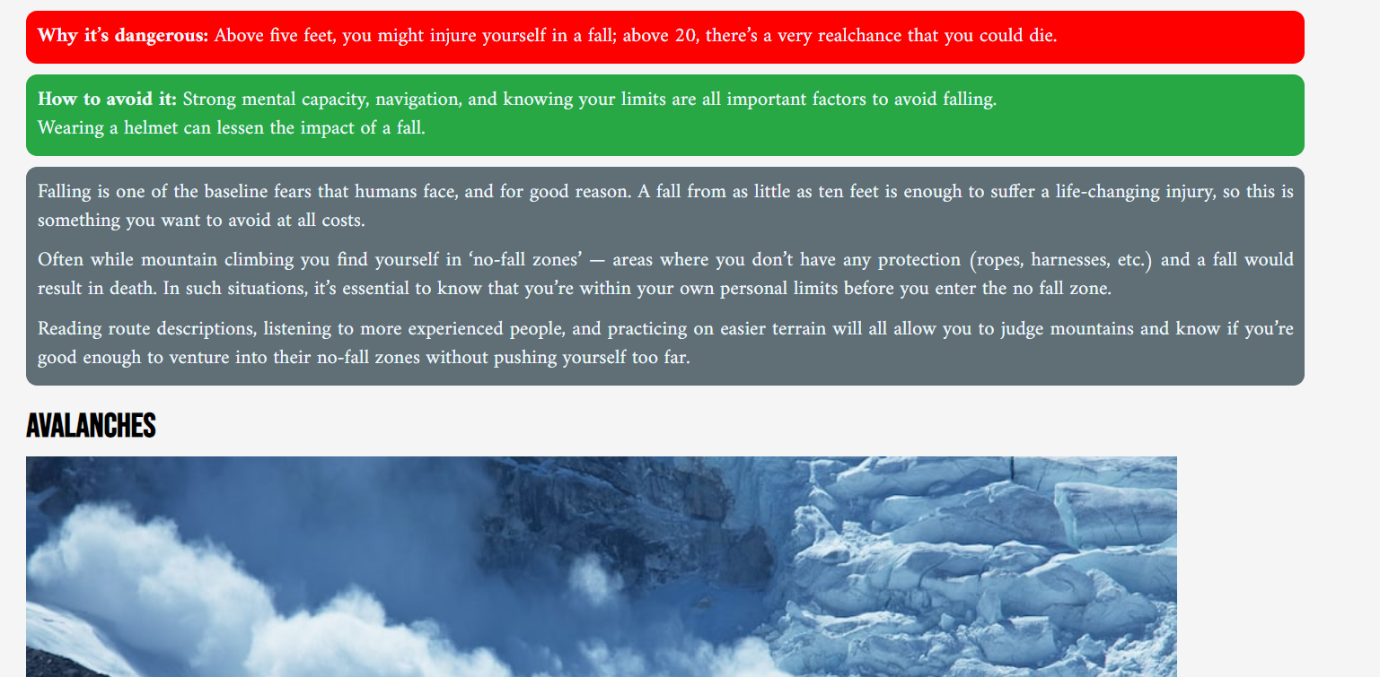

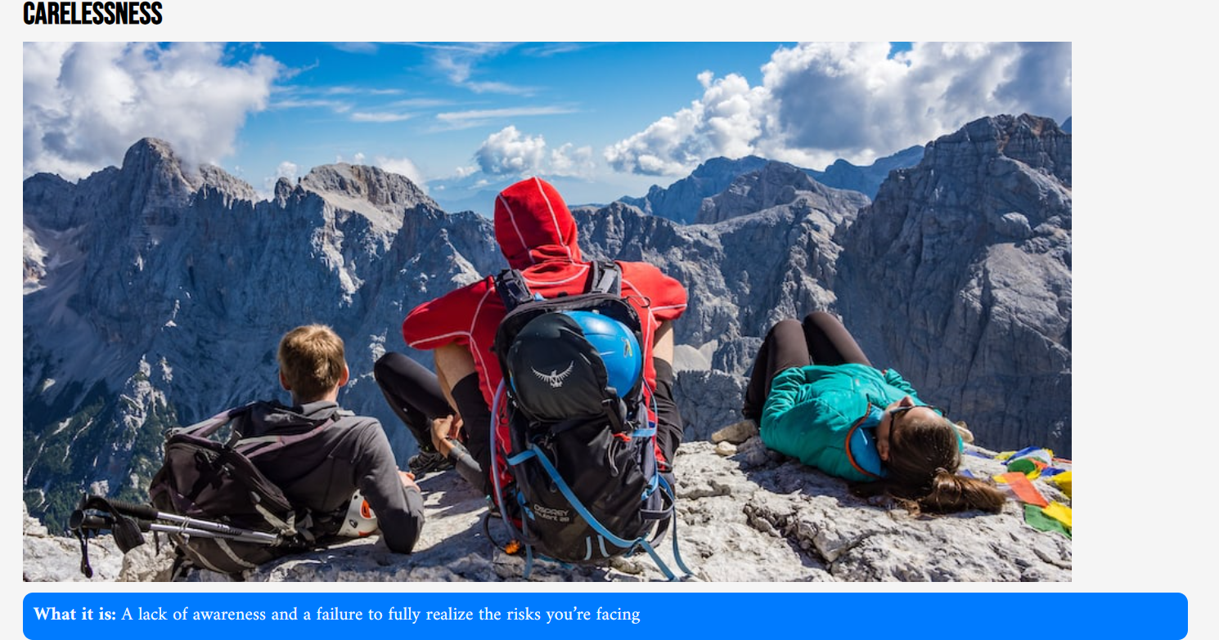

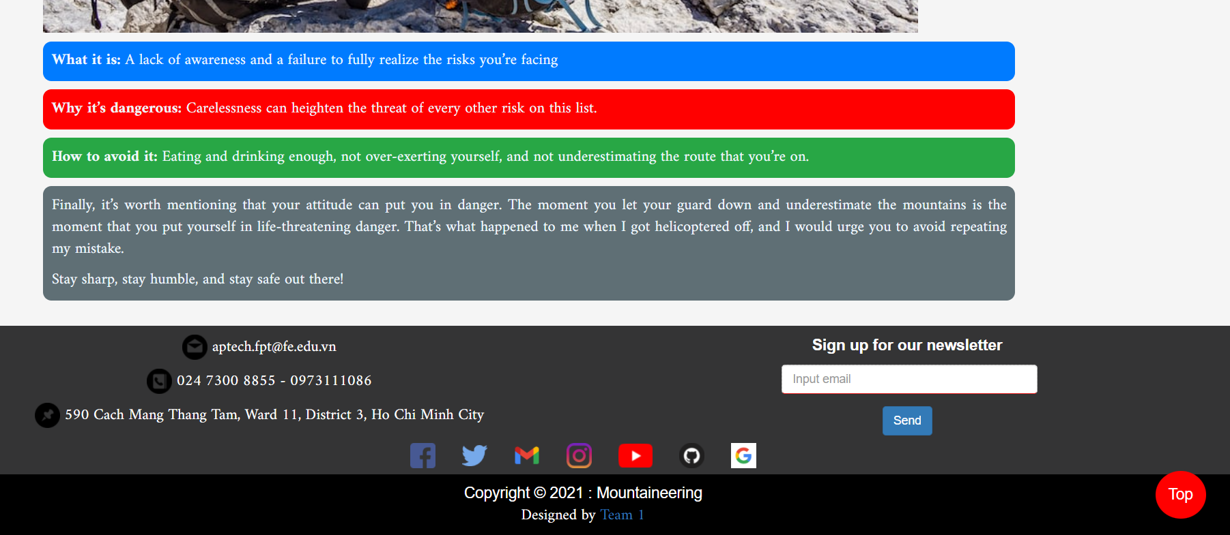

1. Organizations
   1. **Description:**

**+** Show some groups/organizations/clubs/ that arrange mountaineering to various locations in different areas across the globe

**+** Show contacts informations of said groups/organizations/clubs

**+** Show some achivement/succesful stories of said groups/organizations/clubs

* 1. **Screenshot:**

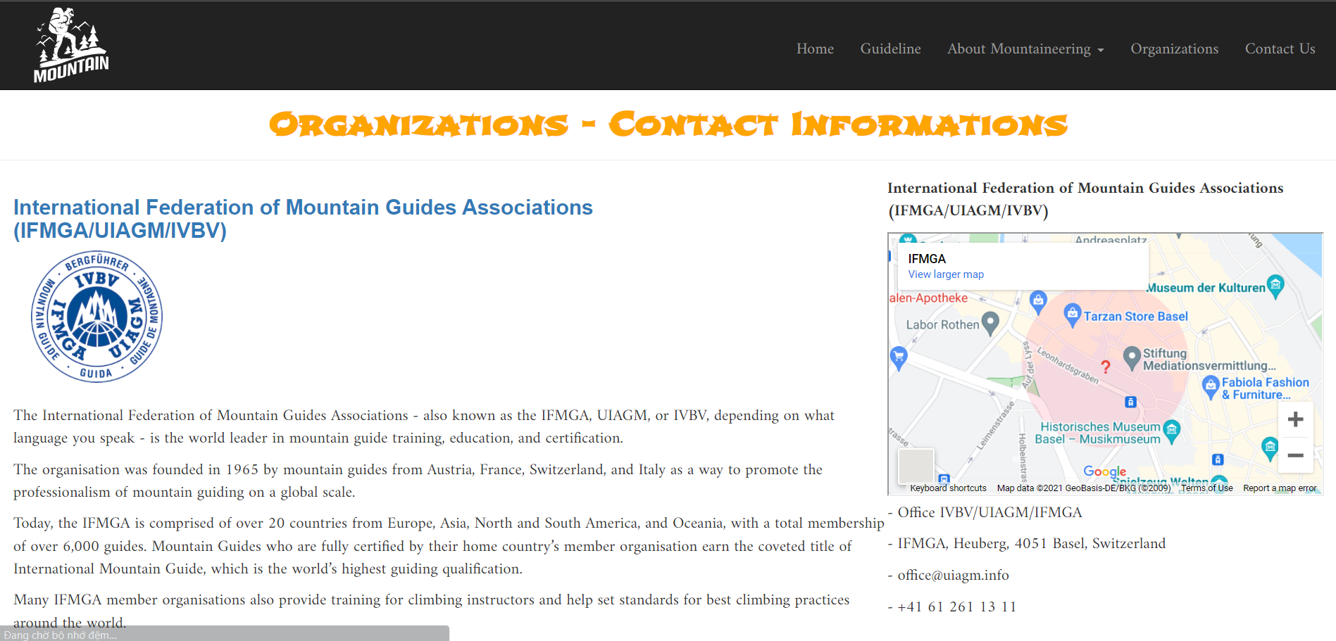

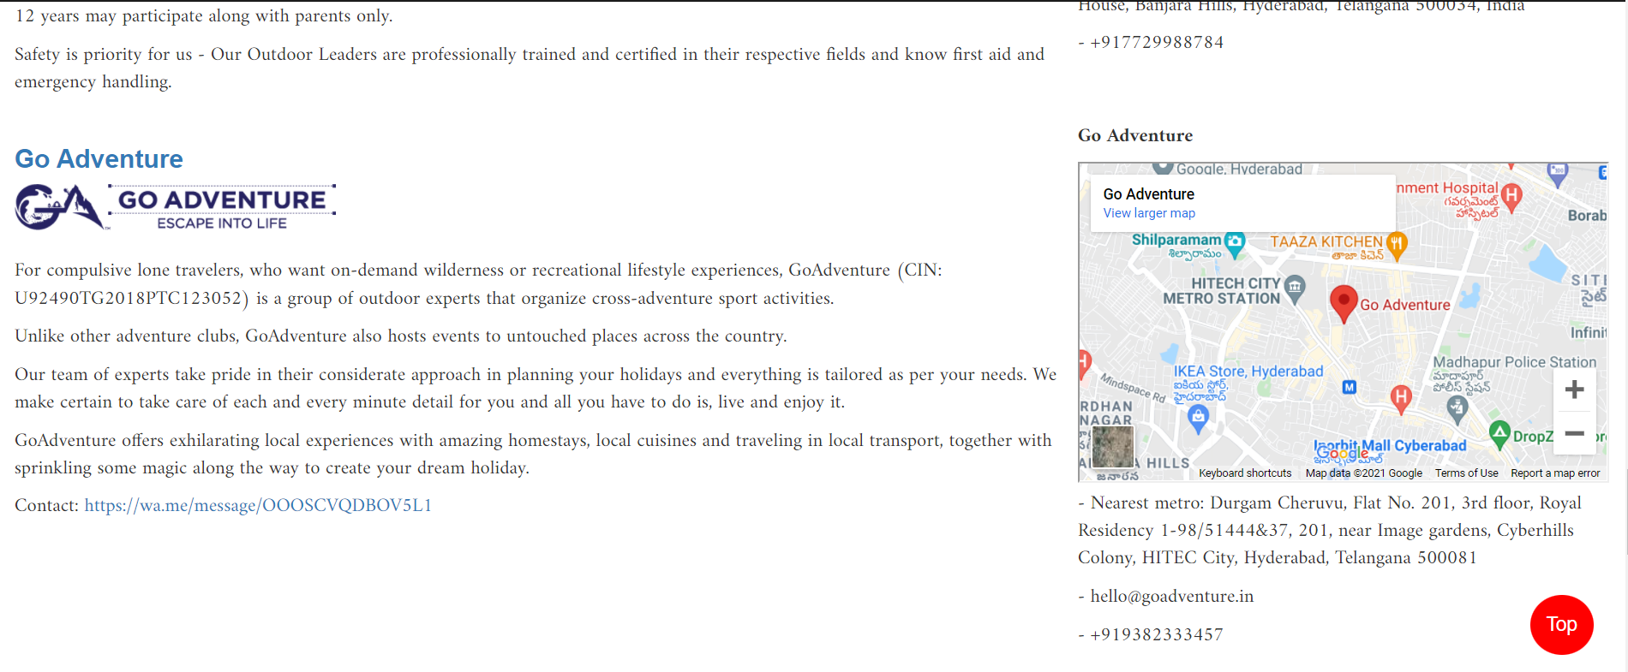

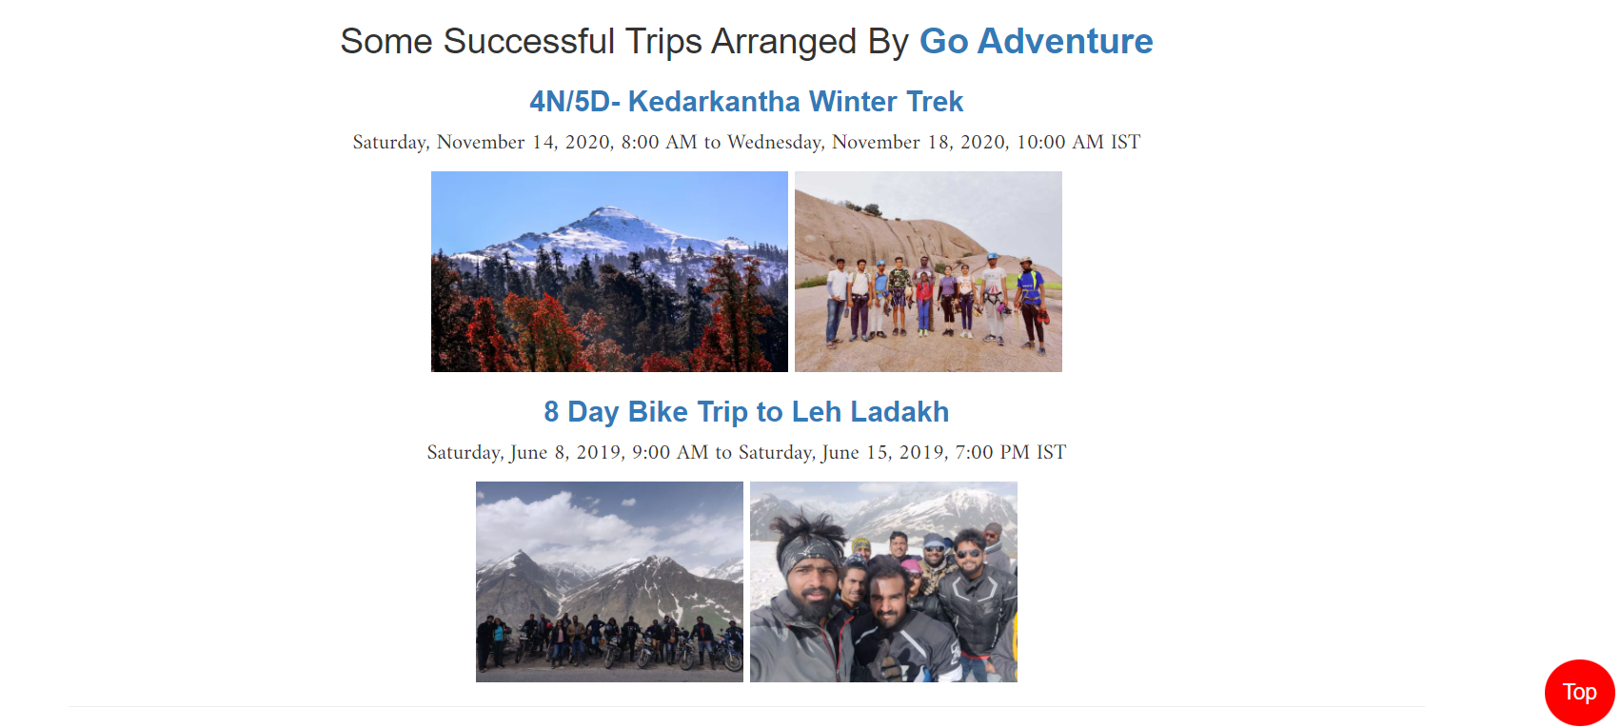

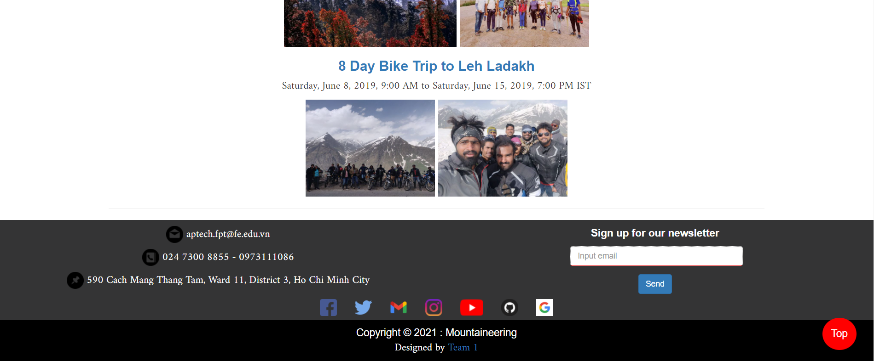

1. Contact Us
2. **Description**
   * + - This page displays contact information: location, telephone number, email and website
       - A quick contact form for customer
       - Group contact information
3. **Screenshot**

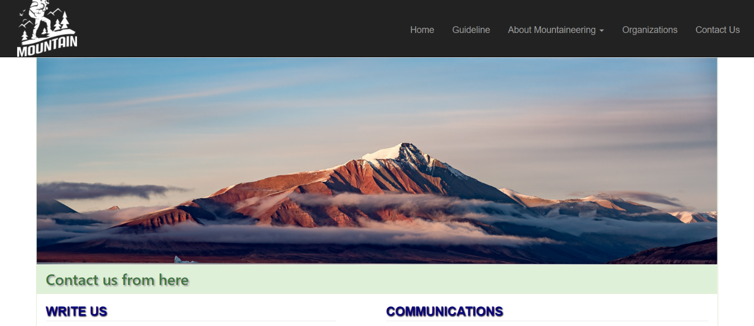

|  |
| --- |
|  |
|  |
|  |
|  |

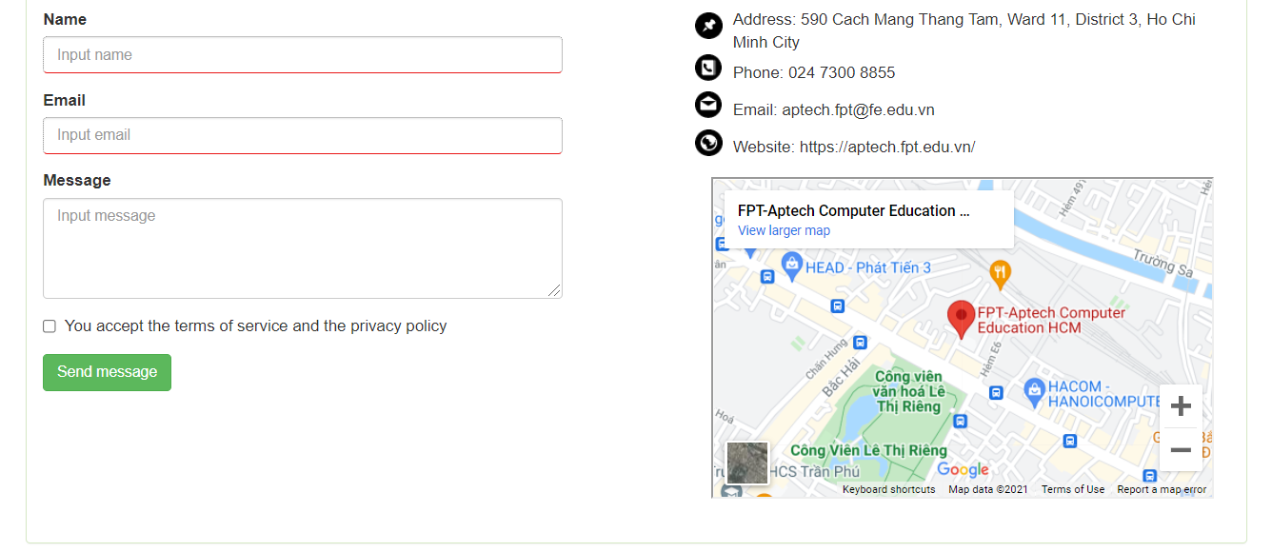

JAVASCRIPT DESCRIPTION

1. **Contact us javascript**
   1. Description

This script used for contacting to our customer service.

* 1. Screenshot

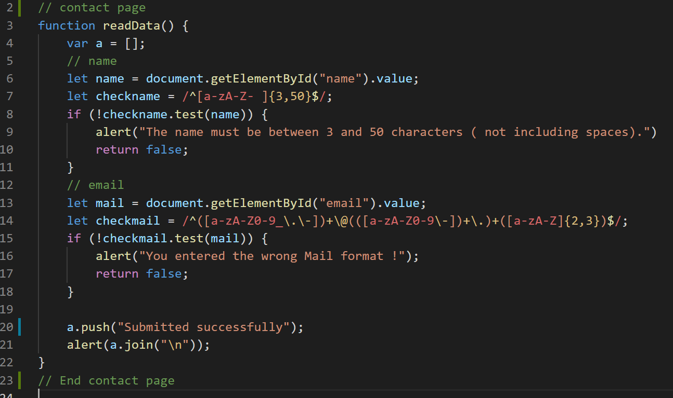

1. **Button Top javascript**
   1. Description

This script is used to return to the top of our page.

* 1. 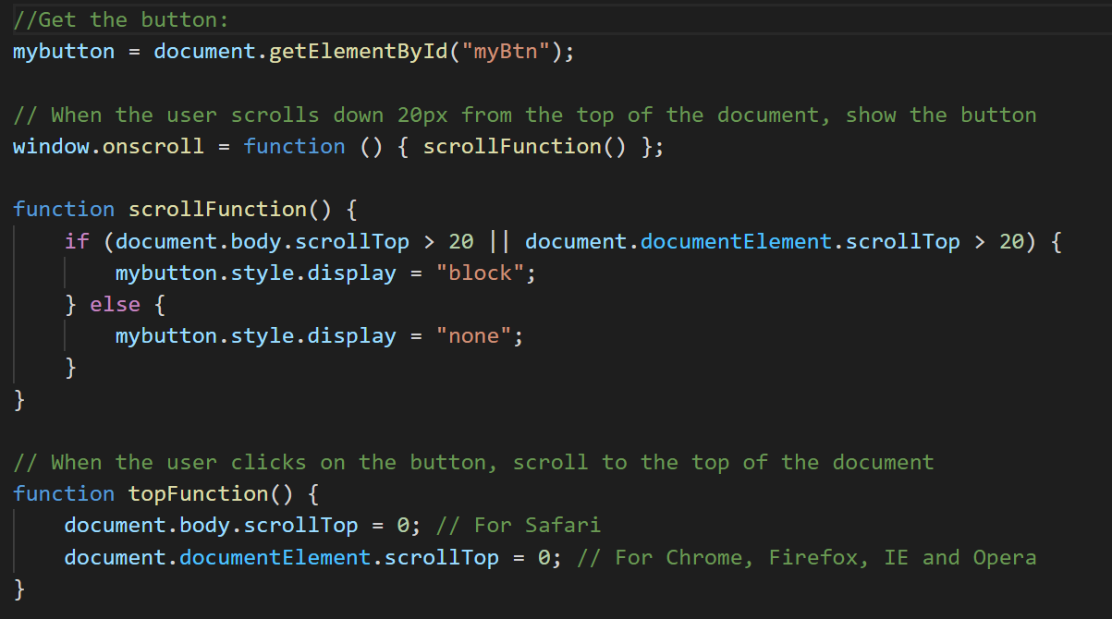Screenshot

1. **Footer javascript**
   1. Description

This script is used to register with us.

* 1. Screenshot

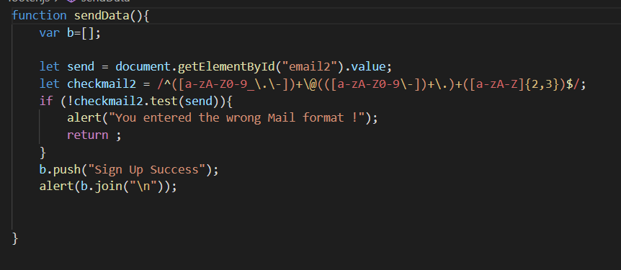

1. **Carousel javascript**
   1. Description

This script is used picture slideshow.

* 1. Screenshot

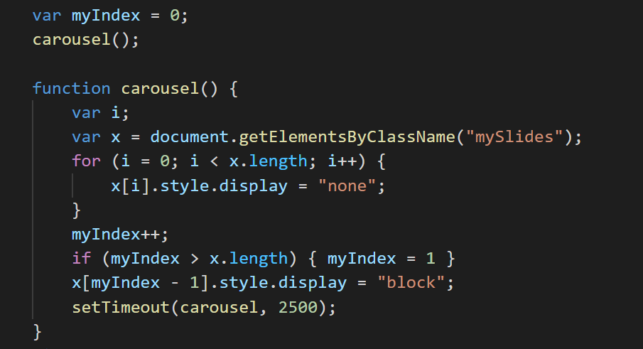

**TASK SHEET REVIEW 3**

|  |  |  |  |  |  |  |  |
| --- | --- | --- | --- | --- | --- | --- | --- |
| **Project Ref. No.:**  **eP/Advertisement**  **Portal Management System/01** | | **Project Title:** | **Activity Plan Prepared By:** | **Date of Preparation of Activity Plan:** | | | |
| **Sr.**  **No.** | **Task** | **Actual Start Date** | **Actual Days** | **Team Mate Names** | **Status** |
| 1 | Website layout | Mountaineering | Nguyễn Văn Khoa | 28-Nov-21 | 8 | All | Completed |
| 2 | Edit CSS | 28-Nov-21 | 5 | All | Completed |
| 3 | Modal javascript | 28-Nov-21 | 5 | L.T.N.Huyền | Completed |
| 5 | Task sheet review | 20-Dec-21 | 2 | N.V.Khoa | Completed |

|  |  |
| --- | --- |
| **Date: 22th Dec 2021** | |
| Signature of Instructor:  **Ms. Le Mong Thuy** | Signature of Team Leader:  **Nguyen Van Khoa** |

